Snappy wing

# Analysis

## Identification of the problem

The problem I will be solving is a game that is liked by many. The concept of the game will be a spirt/avatar that will be jump after an input that. The game is a casual game that will last from about 1 minute to 2 minutes for casual skilled players and is a side swipe game in which the background moves and generates random obstacles that will have to be avoided by the player. The game will quite similar to the game flappy bird however there will be different customisable features that will apply the characters and the backgrounds. It will contain aspects of other games in which items may be collected to enhance the sprites characteristics, these items being objects of a class similar to the sprite with their own object attributes. The concept of the game will have a timer in top corner of the screen recording the time currently played and an iterative game loop that will continue to loop until the sprite has a collision. The sprite/character will be shown in the middle of the screen then as the game progresses the sprite which is controlled by the player, after they press the space bar will have an acceleration vertically upwards giving a perceived thought of flight or jumping on the air. After a short period of time as the background which is perceived continues to move the obstacles will come closer to the sprite meaning that the player will need to manoeuvre the sprite in order to pass the barriers without touching the walls. If the walls are touched the will be a halt in the game loop causing the timer to stop and game to end like in other similar games. After the end condition is met an animation of the death will be shown to the user and they will be returned to a UI to press if they would like to play the game again. The user will be able to alter how the background looks and also how the sprite looks. In relation to which character a different death scene will be seen. The game will appear as though the bird is moving however my solution to this will be that the background will move through a queue making the bird seem to be progressing.

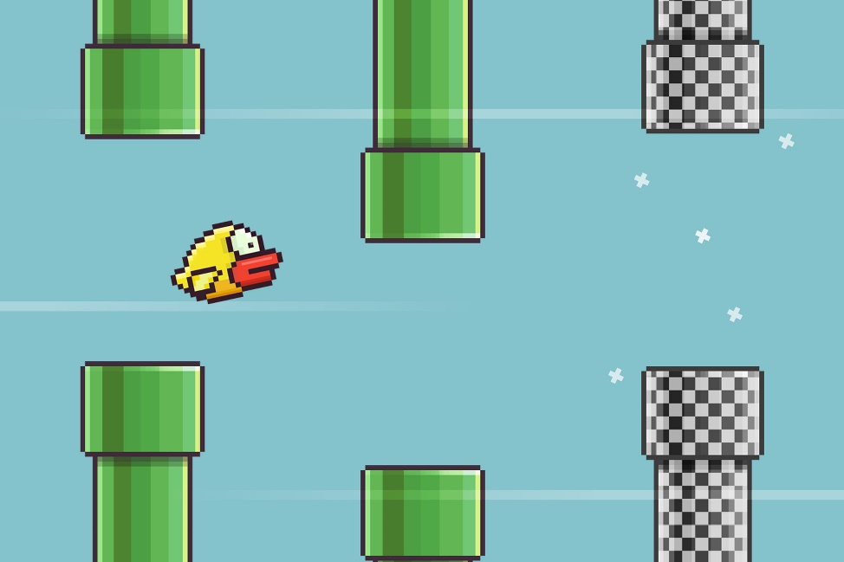

The image shows Flappy bird a solution to a problem that is similar with mine the snapshot shows the barriers and how the sprite would need to maneuverer the obstacles to pass level in addition to how the bird will be seen to be mid-flight by the user.

## Reason for a computational approach

The game I am creating will be well-defined and only able to be in various states like unable to be in the play state and the game over. However, some may be able to overlap and may happen concurrently an example being the play state and incrementing the score happening simultaneously. So Through using various skills like abstraction and decomposition the game can be efficiently solved through computational means.

## Current system

## 

Start Screen

Gameplay begins

## 

Input: Tap to jump

## 

Yes

Collision

## 

No

## 

No

Pass through barrier

## 

Yes

Output: New score

Output: Game Over

Output: Game Over

## 

No

Yes

End

Restart

This is an abstracted representation of the process of what occurs in the old flappy bird. The game process/ gameplay also includes the physics processes that will be handled by UNITY. After the game over sequences the user will have the options to restart playing again. The timer and the score counter will be reset after the game over sequence is outputted. The problem can be best solved computationally since the game is modelled as a computer game meaning it cannot be solved efficiently or effective without computational means. The problem could also have been solved using other programming languages and game engines like Pygame despite having large libraries and many inbuilt functions I am unfamiliar with Pygame’s functions that manage forces and I believe that a lot of the physics components I am planning to add will need to be hard coded in. This could increase the scope of the project unreasonably. However, unity despite often being used and most effective for creating 3D game would have usable features like rigid body and various collisions functions making the game more in scope for an a-level project. A drawback of using Unity is that there will be a lot of the functions that will be unused potentially increasing the memory due to such a large library however the Upsides outweigh the Downside.

## Key processes/ computational methods

|  |  |  |  |
| --- | --- | --- | --- |
| Process | Description | Method | Justification |
| Play/Start | This state will be in action when the start button is triggered. | Decision | The start button will trigger the iterative game loop. It will make the game easier to play for the stakeholders. |
| Paused | This state will be present before the start button is pressed and most objects will be disabled | Decision | Paused will be the state before the iterative process begins. Having fewer states will reduce lines of code and decrease storage for the game. |
| End case | This will occur when the avatar/sprite hits a barrier or the user doesn’t provide any input resulting in the character hitting the floor. | Decision | The reason for the use of a method is because the program’s iterative cycle will end due to the game needing to be restarted. This will make the game have clear stages and the improve user experience. |
| Jump animation (gravity) | After the jump occurs some force will need to be applied to the sprite reducing its y level on the screen which can be seen to be similar to gravity however instead of attraction to the largest object the force is always applied downwards . | Abstraction | The resistance will seem like gravity however will ignore other factors like air resistance that would also apply in real life circumstances. Unity will make this easier due to inbuilt libraries of function. |
| Increase score | There will be a score counter that is incremented indefinitely when the bird passes through the barrier to create a score. | Decision | This will be key making the game competitive and in tracking progress to improve user experience and make the game competitive. |
| Animation/game loop | The game will continue to play unless the end case is reached. | Iteration | The game will continue to play unless a condition is met (The end case). |
| Upward Force | This force will be greater than the force acting downwards which causes the sprite to have a higher upwards force than the downwards force. | Abstraction | The Upwards force is a simplified version of flight and will ignore many natural factors like air resistance and other like forces however it will be used to counteract my form of gravity. |
| Barricades | The barricades will be generated and will cause the game loop to end if touched.  continue to used and potentially altered | Data structure (Dynamic queue) | The reason for a data structure to be used is that the barricades will likely be reused but just altered slightly meaning a dynamic queue could be used. |
| Player Jump | This will be a player driven action that when the button is pressed it will cause a burst of acceleration to occur to the player giving the impression of flight. | Input | The reason for this will allow the player be able to interact and control the upwards force applied to the bird. Visual studio code will allow me to make a program to manage the inputs of the user. |
| Game over | This will occur after a collision and will show a screen to the user to inform them that the game is over. | Output | The screen would be used to help them also load into a new game to improve user experience |
| Restart | This will be the decision made by the user on whether to restart the game or end | Input | This will give the user more control over the states that the game can be in |

## Stake Holders

### Interviews #1

Princess Borishade (age 20)

Occupation: Farmer

Developer – “Hello Princess”

Princess – “Hello”

Developer – “What is your intake with the current flappy bird game.”

Princess – “I downloaded the game late 2018 and since then it’s become my most played causal game. The game can be played anywhere and literally anywhere which can be beneficial due to my profession and it rigorous nature. I even let my young children play it and it can provide a period of peace as they are engrossed into the game”.

Developer – “It seems you really do enjoy the current game however do you think the game would benefit with updates like power ups and potentially inverting the controls to add harder settings”.

Princess – “As much as I enjoy the current game the game is becoming really repetitive and not challenging to my skill level. As much as it is great new players and a younger audience I would love to see the game go through more updates which challenge experienced users like myself by having different difficulties and modes to bring back the excitement.”

Developer - “Thank you. In addition, how do you feel about the aesthetics of the old game right now and would the game benefit from more customisable characters.”

Princess – “The games aesthetics has not really changed much since its creation which is beginning to make the game feel quite bland so it would benefit heavily from having a change of style making it seem modern and more suitable for the time. I would also love the addition of new sprites and different colour barriers since it has remained the same since 2018”.

Developer – “Thank you for your contribution.”

### Interview #2

John Smith (15)

Occupation School student

Developer – Hello John

John – Good afternoon thank you for having me

Developer – I hear you are quite the computer science enthusiast, so what do you think made flappy bird so popular

John – There was a mix of thrills offered by the game but for me the easily progression and test on mental endurance was thrilling and the just “One more try” feeling was truly like nothing else.

Developer – What device or devices are you going to be playing snappy wing on

John – Since I am only a school kid I will be playing the game on many different devices so if the game is run at 30Fps frame rate it will ensure that all my devices will be able to run the game and its program

Developer- What do you think that the developers can learn from flappy bird

John – The main lesson is that simplicity sells, complex and fancy game mechanics aren’t always the key to successful games but just the feeling of competitiveness even with one’s self can make a great seller

### Quiz

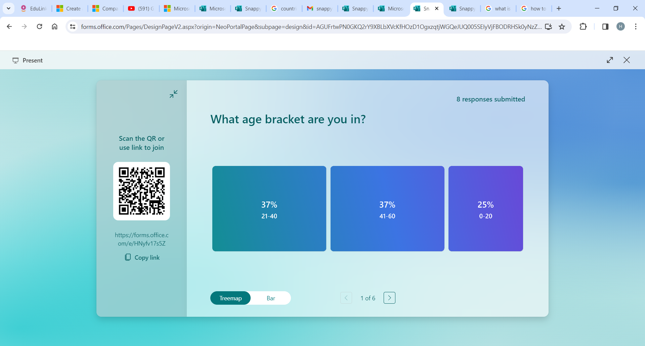

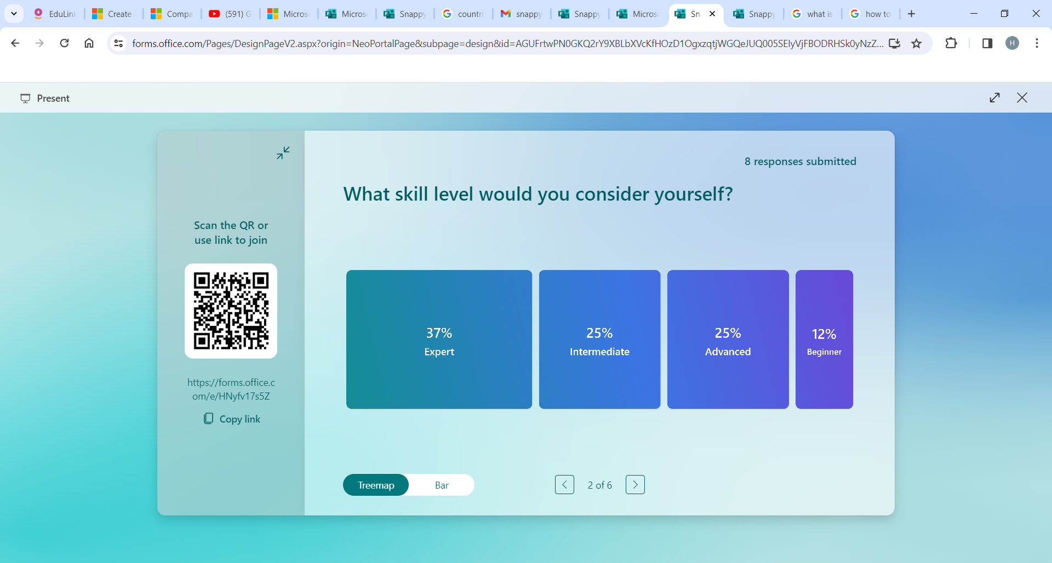

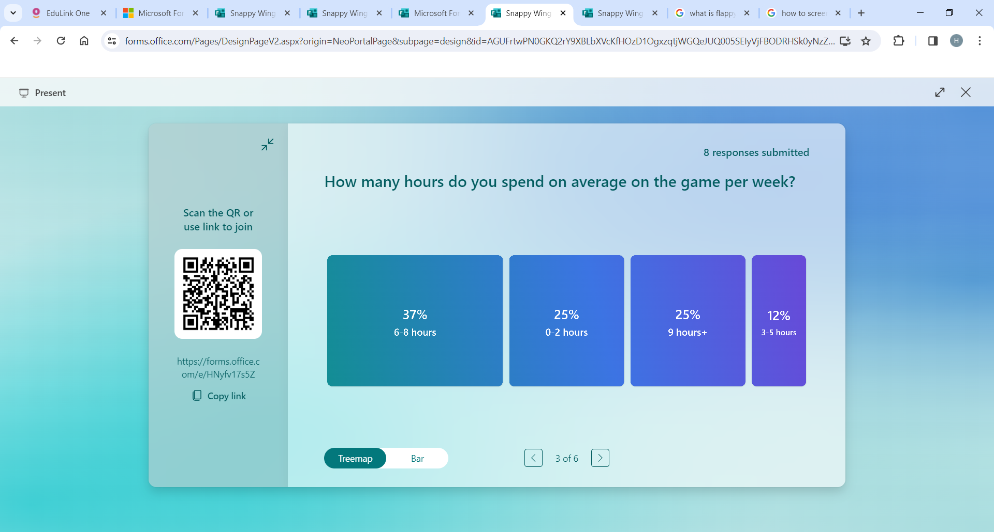

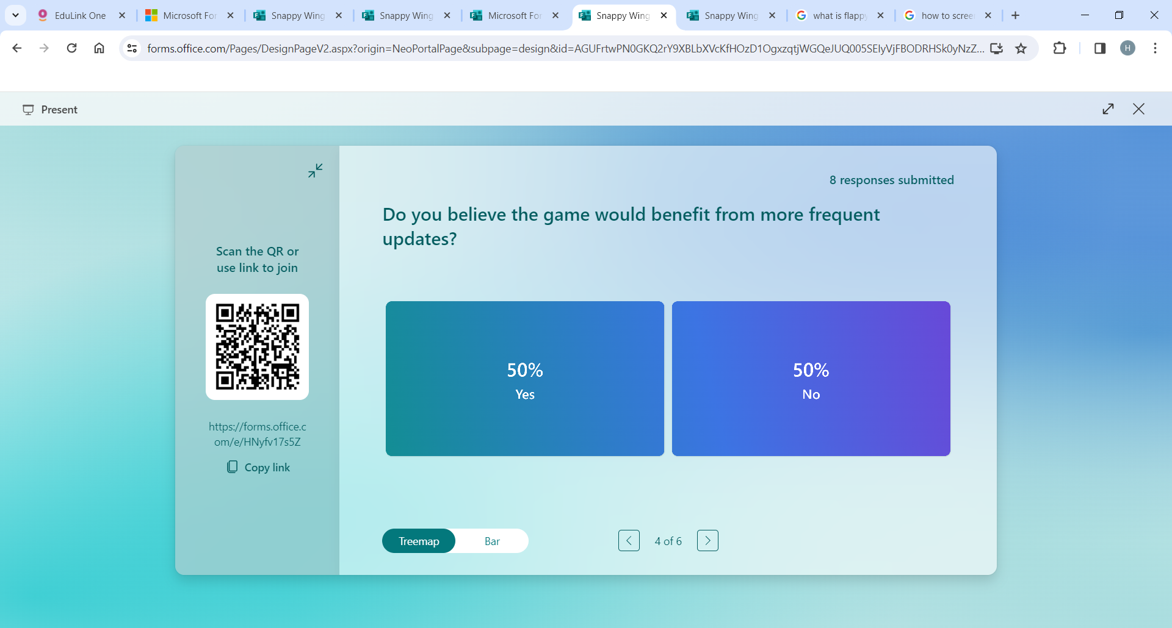

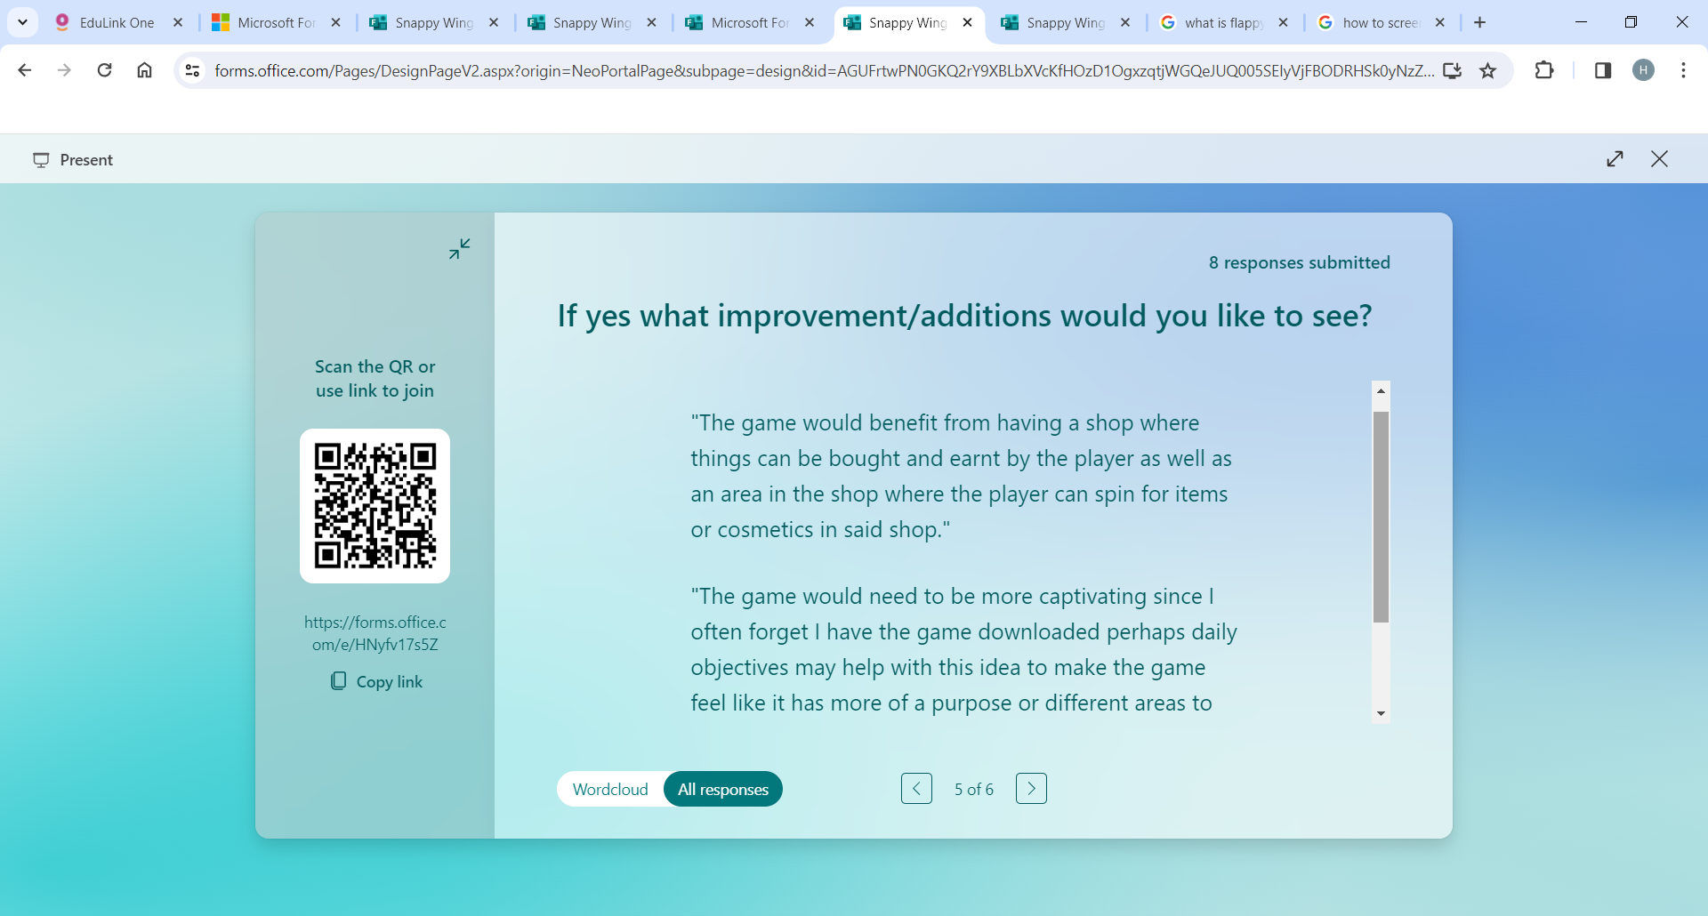

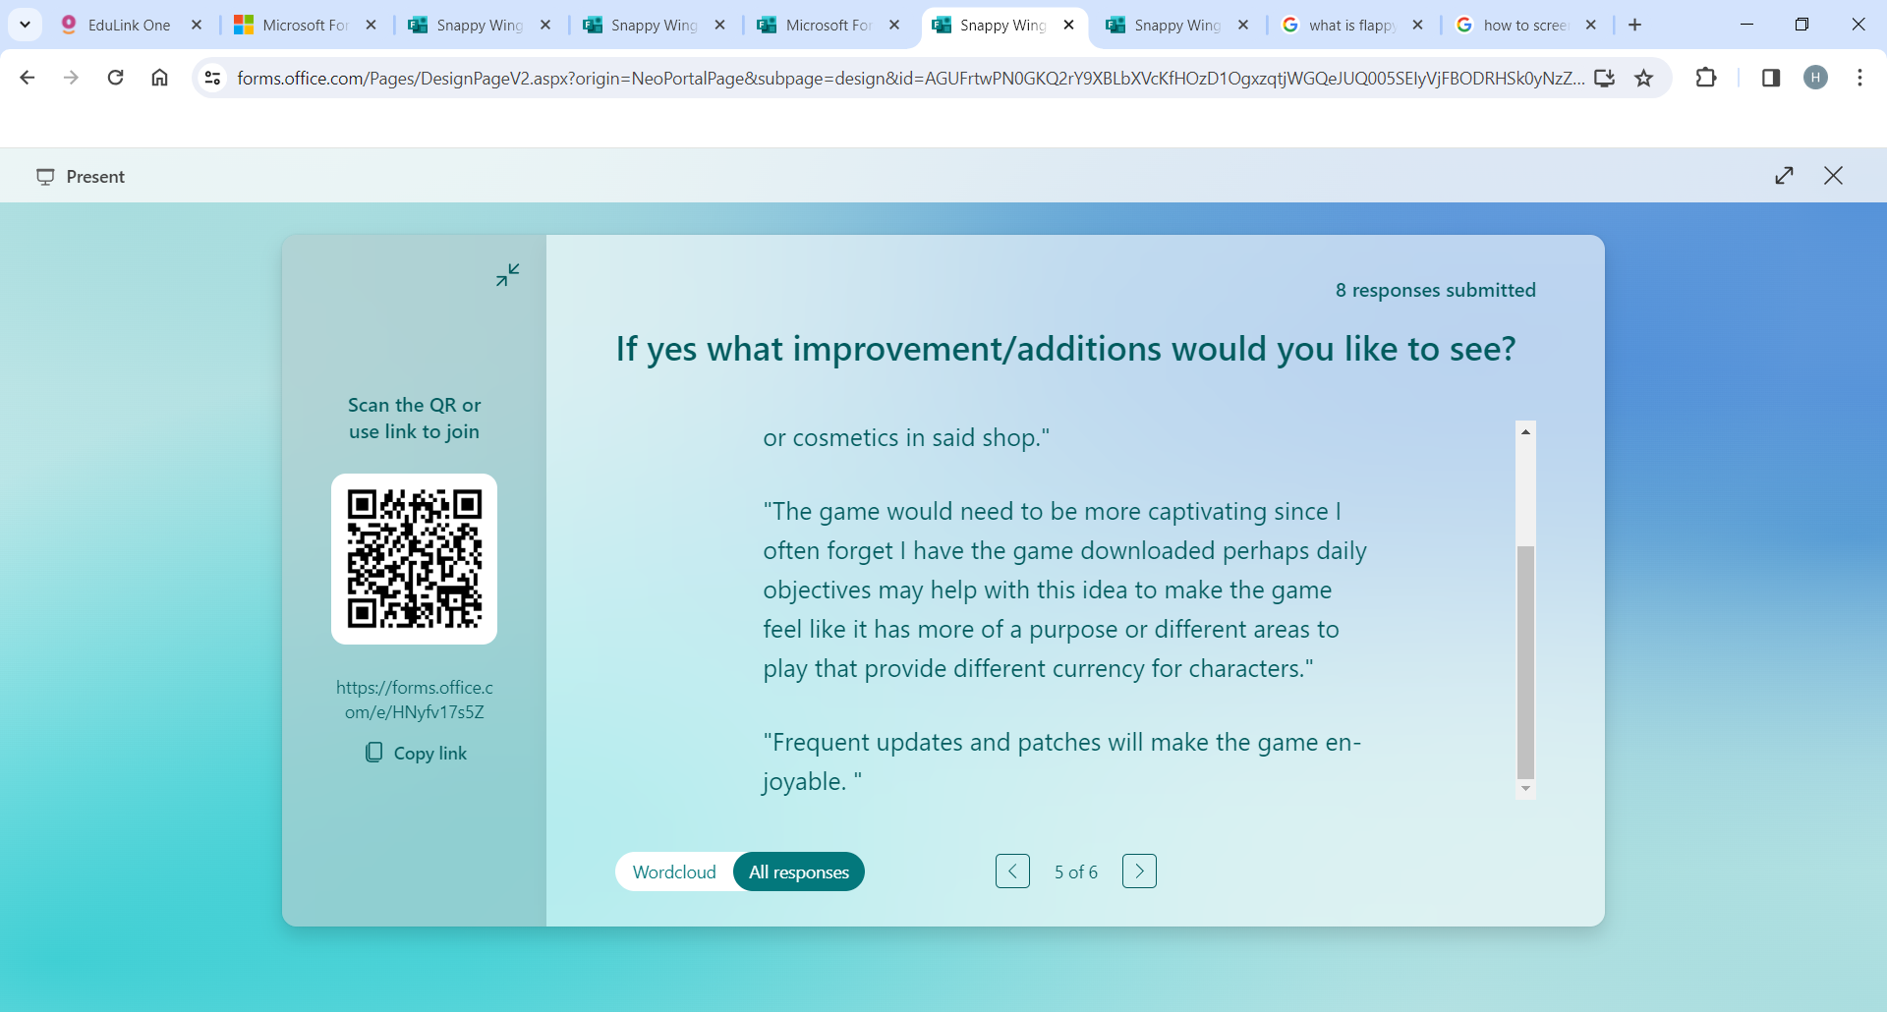

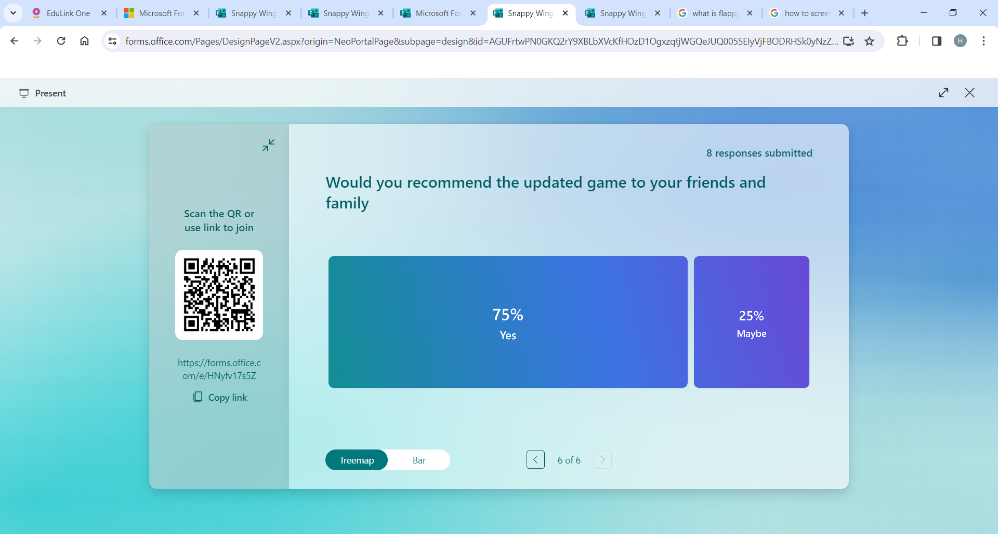

### Quiz review

The quiz has been very helpful and has given me on additional ideas and improvements that can be added to the game as both ideas for its purpose and functions, and its design. The idea of a shop for the game will certainly add more appeal to the game and make it more hooking for the users that will play it. However, having the option to spin for items may increase the scope unreasonably and despite it appealing greater to a certain group of people it may not to all my desired users in addition if the shop was created the project may escape the scope of being an a-level project. The quiz however shows that they will be a want for the game production and how it will be received well by the community.

### Interview review

The interview made it apparent that people from all ages are interested and not just people under a certain age showing that the game will be a necessary solution to the problem. This is made apparent through the success of other games similar to it like subway surfers and flappy bird. The interview also highlighted the support for simple games that can be played anywhere without much preparation and the ability for it to be dropped quickly without having to save progress. It was also flagged up that the game should be kept as small as possible to make sure that it can be run on a range of devices since a lot of the clients aren’t very wealthy or are in school meaning they won’t have high quality devices with large RAMs and CPU’s. Many of the users may try to play the game in schools meaning that the game will need to be able to operate on school devices so I will make sure to take the specs of the average school computer is taken into account. The interview also showed the want for some of the audience of their being an increased challenge to appeal to more experienced users. This may be incorporated via means like power ups.

## Research into problem

Temple run is a fully functional game created in 2011 with an interesting concept of a man running endlessly passing through an ancient looking terrain, avoiding obstacles and making sharp turns when required. Temple run is similar to the game I am planning to create since they are both endless runner games. However, I like the coin collection system in the temple run and think that the same concept can be applied to my game. It may be difficult to find a suitable design that would fit the theme of the screen but it will be a nice addition to the project. More lines of code will need to ensure that the coin in-between the barriers disappear after they are touched. The unique camera angle and the mechanic of getting slightly grazed are both interesting and would make a great addition to the game however both may be outside the scope of the project more time than allotted will be required to polish this feature. The same problem arises when the concept of something chasing the bird. It may improve the competitive edge to the game but will be too code intensive and a nodal system may be needed to make the chasers path finding good enough to evade the barriers. The addition of something chasing the bird would be meaningless if the chaser could never catch the bird under any circumstances unless the bird has a collision. In addition, I would like to add collectables that will be used to change in game characters and power ups to add short time game advantages. My stakeholders would find this feature very fun in addition to this I will be able to make the power ups using a-level techniques like object orientated methods a template of a power up can be made and used to make various different power ups with different effects. This would be challenging to complete however I don’t think that the addition of power ups will be outside of the scope of the project so it will be a great addition despite the additional time required. In addition to this I will like to take the sliding screens from geometry dash with the which change colour however that will mean I would need to have a procreated screen full terrain meaning that I would not need to loop through the background defeating the purpose of sliding screens that I was originally going for so despite it being an interesting feature it will be left out as it will cause to project to take a different direction to what the stakeholders want and what I want to achieve. It would be effective in showing how the difficulty progresses but would this can be shown in other ways rather than by change of colours. I would love to also add a lot of different songs that would play randomly during the game like geometry dash however I would not want to be copy righted by musicians and I am unable to make good sounds that would match the scene. In regard to that I will likely have a limited number of songs if any so it may not be a practical addition to the game. It would improve user experience so if some songs are available they will be implemented.

## Similar solutions and their similar aspects

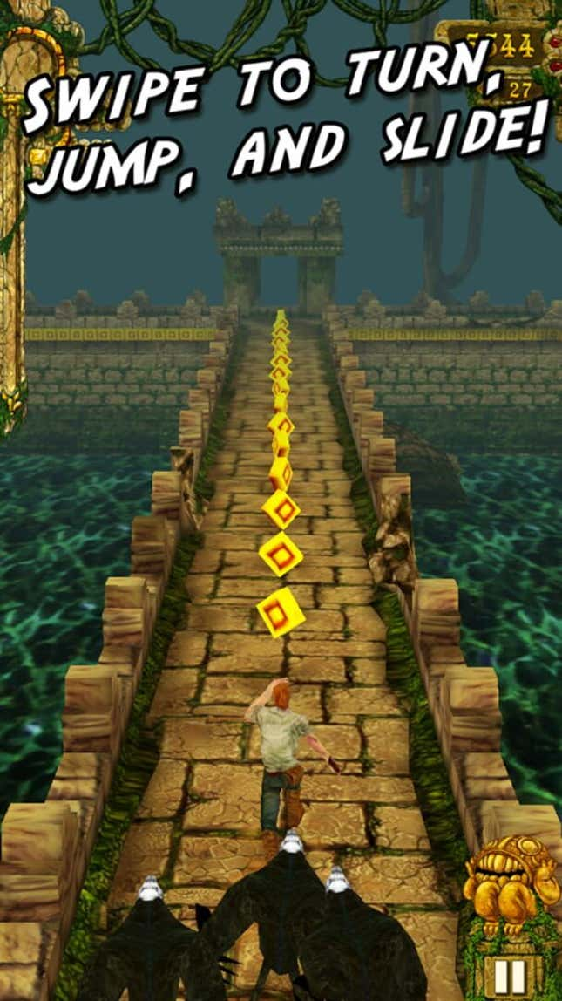

Gold coin that will be between the barriers

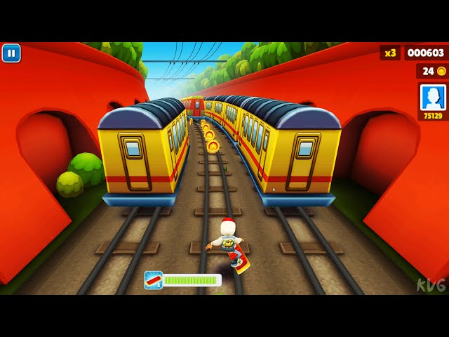

The Score UI will be in the top middle of the screen

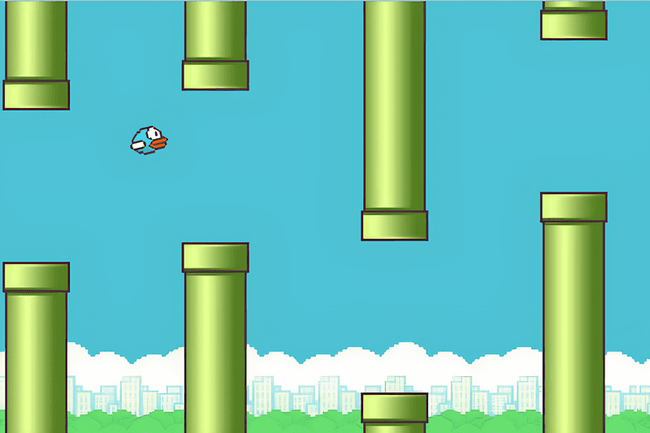

The barriers will spawn and delete when off the screen

## Essential features

The essential features of Snappy Wing will be the screen angle. Originally the plan was to add a 3D perspective to the user’s gameplay similar to games like the Temple Run which would introduce have introduced a new perspective to the current game. However, I do not have much experience in the creation of 3D based games so I would have needed to tackle a steep learning curve which would take me too long to learn which would make the project take longer than the allotted time available, so from this I have decided the game would be best completed being a 2D side swipe format. Computationally Unity will make it easier to make POV of the player in the 2D format previously stated. Unity has various inbuilt features that control how the screen looks and it can be easily manipulated to give desired results based on the code written in. In addition, it can also manage how the screen will be viewed correctly to make far away objects render at the right time. The feature is needed because Flappy Bird’s perspective can be seen as outdated to how games have progressed.

I would like to add power ups that allow the player to feel more engaged. The power up will be defined as an object that when collided into will produce an effect on the sprite. I have chosen this to be added rather than improving aesthetics since I will be able to incorporate more computational techniques like object orientated programming. I could have chosen to program the power ups procedurally and though that may be simpler if I am only making one power up in addition to me also having more experience with procedural programming using objects would be more effective when making multiple power ups, the since all power ups will have similar methods and the only values that may be altered are its attributes. If the methods need to be changed polymorphism can be used. The power ups will each have their unique methods and attributes that may apply different status effects for different periods of time based on which power up it is.

Another important feature is that when the visual of all of the power ups to look different so it will be discernible to more experienced players. The point of this is to make sure the players don’t feel the same restriction as they do in the classical flappy bird game and they get a greater sense of freedom. This will make the game more engaging. (The computational solution to this would be to create a new game object that would be the power ups and create a script that would ensure that when a collision has occurred between the players sprite and the power up some change will occur. This change could happen both to the game loop or to the player’s script potentially altering some of the objects attributes).

Furthermore, another essential feature is the system of there being a single button to control the upwards movement of the sprite when there isn’t a power up in place. Having a single button to control the sprite will ensure that all users will be able to use it since most personal computer set ups have a mouse and or a keyboard meaning no addition hardware will be required. The button will control the output of a temporary upwards force that will cause for there to be a temporary upwards resultant force to go against the initial resultant force that went in the direction towards the floor acting on the sprite. Unity will make it easier since they have an abstracted version of the physics that can be applied to different objects including the sprite. Using components like RigidBody2D will make this easier. (The computational solution will be abstraction of gravity as well as being able to apply a force onto the bird when inputted. We will need to be able to be able to change the values of the bird’s transform y level in the script and apply the force when clicked.)

In addition, the bird animation is an essential and will be seen to be a series of looped still images too fast for the users eyes to notice giving the illusion of flight. The bird will have at least three or more states one with the wing down then in the middle then up and will be looped through. This will make the game better for stakeholders and I will be able to use iterative processes to make this happen. (I will use a normal array present in the sprite render component already on Unity but I will make a script that will loop through the sprites in frequent intervals)

Another essential feature will be the gravity. I could have hard coded the physics of gravity myself giving me more control over the exact proportions and I can even alter the rates it is applied to the sprite however I have decided it will be a better use of my time using Unity’s in-built system as it has a pretty good concept of the physics behind it. I am unfamiliar with how to manage terminal velocity on Unity’s system however with the time saved it will be a better use of my time to use the game engines’ functions. The gravity will be applied to the sprite every second and will be multiplied giving the illusion of acceleration. I am planning to use Unity’s function of DeltaTime for the gravity to be applied because using the normal time would mean that if the game wasn’t played in a high frame rate the bird may seem to stutter which wouldn’t be deemed as a success in my eyes which is why the solution would be to use DeltaTime as the acceleration would be applied consistently regardless of the framerate the game is being played at. Without gravity the game will feel unnatural and the bird will stay in place unable to evade the barrier. (The computational solution here is abstraction. The gravity will not work the same as in real life but an abstracted version will be created and applied to the bird’s Y component in the transform)

Obstacle generation will also be a key feature to prompt the user to input to avoid the barriers. The barriers will need generate randomly in order to make the game more challenging. In addition to barriers will also need to be deleted after not being visible this will be to save memory. This feature will be key in making sure that the game can be played for long durations without slowing down because of the number of entities present. (The obstacles will be generated and deleted in a queue like manner meaning the first obstacle created will be the first obstacle deleted. The obstacles will be an object that should be spawned and duplicated by some sort of spawner. It will have three components the upper barrier, lower barrier and the scoring mechanic in-between them.)

The scoring system is also key in making sure that the user will not need to count the number of barriers the bird has passed. The scoring will be a coin that is present in between the pipes and there will be a number in the top middle of the screen counting the score. (The scoring coin will be objects that are present between the barriers and will hold the decision in their script in order to alter the score value in the top of the screen).

The background will also have some form of a scrolling mechanic and not just an infinitely long background to limit the file size. The background should have some form of a looping mechanic which makes sure the background is only present on the screen. This will be to optimise the use of memory and make the game run smoothly. (The background will be iterative and will have scripts attached in order to change its’ locations).

## Limitations

The game will not have more than 3 power ups one being a speed boost and another being a size increase. Making too many power ups may make the game feel confusing for new players and make it too difficult for beginners in addition despite it potentially not being too much more hassle due to my plan to use object inheritance and polymorphism to create its objects due to the likely duration of each game loop the user may not even be able to use all of the power ups in a single run. While I could take more time making a tutorial stage to make a safe environment where they could experience each power up. However, I feel as though the effort required in its development that tutorial compared to how much it would be used is not comparable making it an ineffective use of time.

Another limitation is going to be the user controls. In some games like Temple Run that have similar components to my game the practicality of having more than one control for the sprite will not likely be a part. This is partly because I think it defies one of the principles of the game and may transform the problem into an entirely new one. In addition to this that game is designed to be enjoyed by all so if the game becomes too difficult it may become off putting to some more beginner and intermediate players. This would also mean that I would need to only program the bird to move vertically making my abstraction of gravity easily applicable to the controls.

Another limitation is the lack of progression in difficulty. The game’s difficulty will not vary much since the game’s concept and is just to avoid the barriers so it will be quite difficult to increase the games difficulty since the barriers position are supposed to be randomly aligned. To improve this, I would have needed to develop an algorithm that was alter the tendency of the barriers appearing in difficult to reach places which would lead to the project growing to outside the scope I want.

Another limitation could be that high scores or previous scores on runs wouldn’t be saved. This would require the data for the game to be saved onto a separate database and reloaded every time the game is booted up despite this feature being useful to use for saved records and it could increase competitive spirit to beat previous record it would serve virtually pointless making a database since it would only store the time they progressed in the game or the number of barriers passed since nothing else would need to be saved to a database.

## Hardware and software requirements

This software will be written using the game engine UNITY meaning that Visual studio code will help me script the game since it is compatible with UNITY. It will aid my programming development.

**RAM** – (4GB) However 4GB is recommended for being able to multitask the applications that will be open such as the game engine and the code editor. The game will be able to work better and without lag with 4GB or more of RAM. This will also be compliant with my stake holders.

In addition, the game will be future proofed since if any updates are added having a sufficient amount of RAM will be necessary to uphold the quality of the game.

**CPU** – (dual core) A multiple core processor is recommended to handle multitask processing and since the game won’t be too processing intensive it a dual core will be more suitable to handle the processes. This will also be compliant with my stake holders

In addition, 2D games don’t require much processing power unlike 3D games since 3D game have to handle things such as shadows and rendering which require a greater processing power whereas 2D games aren’t very intensive on the CPU.

**Keyboard and Mouse** – The keyboard will be required to move the sprite’s location on the screen via the jumps and the mouse will be used to interact with the UI. Both the mouse and keyboard should be USB connect ports and should have a device driver so the system can interact with the device. The reason I have chosen this is because most computers have a mouse and keyboard readily available. This will make the game playable by almost everybody.

**Adobe Photoshop -** I would need Adobe Photoshop to be able to make sprites and create backgrounds that can be used in the game. It will allow the image to be easily imported into the UNITY since they are compatible. UNITY also has functions that when the image is updated the application will automatically update it on the game engine

**UNITY** –The game engine will be needed to handle the game intensive design this includes aspects like the physics that the game will handle in addition to handling collision collisions between the objects and the backgrounds. The application will be key to managing all the game mechanics of the game since attributes and methods of the objects can be controlled through the Game engine and scripted using visual studio code. I have chosen this over using pygame since it will be a great experience to learn how to use game engines despite me having previous experiences with python.

**Visual Studio –** This software can be used alongside the game engine UNITY to script some characteristics of objects. It will also allow a great experience to program with a C language compared to using python which I have experience with.

## Success criteria

1. For the project to be a success the game will need to be playable and able to be functional and robust enough to not have bugs or ways that the game can be crashed. This would account for the younger and more inexperienced user that may not completely understand the game completely from the off. Choosing to account for a wider range of audience will let the game be a greater success and increase the number of users that would try it. It may have been quicker if I had just accounted for the game to be played by experienced users since I will not need to focus on the robustness of the games process. However, it would be a good investment of my time to account for this.
2. The game should also be able to run on multiple devices with differently powered CPU and different sized RAMs this will ensure that my stake holders will be able to enjoy the game regardless of the wealth or financial background. This will be key to allow user to play it on a range of devices. I could have only focused for the game for users that have better PC’s since it wouldn’t affect them as much if the game was in a higher resolution due to them having a greater memory capacity. However, I have decided to focus on reducing the memory requirement for the game meaning a wider range of people will be able to play the game. (An example being making the instantiated barriers delete once reaching the edge.
3. Another success criteria of the game are that the game can have a clear progression system with only certain elements of the game are moving at a time. Having clear stages increases usability of all the game making. This consists of the barrier and the ground both appearing to be scrolling effectively and at a consistently at a fixed rate. This aligns with the wants of my stakeholders. I have chosen for the screen to move like this because it makes the game feel iterative which was a desired outcome for the code.
4. I want the game to be aesthetically pleasing for the user and for the game and background to seem realistic. This is because having a clear colour scheme improves the usability of the game making it clear to the user what objects are to be avoided in contrast to the bird they control and making sure that the obstacles do not blend in with the scene. This follows suggested by my stake holders. It would also be considered a success if there are different customisable scenes rather than just a single scene because it will make the game more suitable for people that mat suffer some sort of speech impediment like forms of colour blindness. This will also be easily achievable through the software I am using.
5. I also want to game to have some system where the gravity and or the distance travelled by the user per jump is multiplied or divided by some value after criteria is met. This can be seen as some sort of power up. It would be ideal if this system was created via Object orientated programming since it means many different effects can be created using the same class and various techniques such as polymorphism to change its properties and methods but overall just have some multiplier. I have decided this is suitable for the program because It would add an additional layer of difficulty requested by the stake holders and could be a point of difference for the game. I have chosen this to be success criteria over making some other point of difference like a multiplier for the score since a score multiplier may be seen as boring to my stakeholders who would want more of a challenge. A downside for making power ups would be that more code would be required to create adequate classes and it may take the game outside of the desired initially planned scope however if it could be completed it would be a great addition. If this criteria can’t be fully completely completed by the end of this project the power up feature will surely be added in future updates.

# Section 2 Design and Nature

## Design objectives

The design objectives are going to be direct representation of what was mentioned in my analysis of my project. However, I will like to display the instructions of the game in the initial screen of the game and hidden from the user as the game begins to preserve user experience. This will benefit my stakeholders since they may need aid before starting the game

## Main problem into sub problems

Main problem

Snappy Wing

### Sub problems

Bird object

|  |
| --- |
| Player |
| Attributes:  Transform  Box Collider 2D  Sprite renderer  Rigid body 2D  Sprites list  Direction  Gravity  Strength |
| Methods:  Bird flapping()*The bird sprite will get changed after some time has passed*  Jump()*When the input is pressed the bird will jump based on strength*  Gravity()*The bird will get gravity applied based on time and gravity downwards. *  Collison detection with Obstacles()*There will be a constant loop that checks if the bird has hit an obstacle and there will be a signal sent to the game loop to change the state that the game is in.*  Collision detection with Score()*There will be a loop that constantly checks if there is a collision with the invisible barrier between the barriers* |

|  |
| --- |
| Pipes |
| Attributes:  Transform  Sprite Renderer  Box Collider 2D  Rigid Body 2D  Speed |
| Methods:  Left Edge()*The screen left most edge using it’s x co-ords*  Pipes Movement()* There will be a timer that will increment based on time and the speed attribute updating the position of the pipe*  Pipe deletion()* The instantiated pipes will be deleted after reaching the end of the screen and going out of frame*  Collision detection with player()* The method controls what happens when the pipe and the player collide. In the case of this it will send a signal to the game loop and cause the loop to be halted before waiting for further input.* |

|  |
| --- |
| Spawner |
| Attributes:  SpawnRate  MinHeight  MaxHeight  Pipes |
| Methods:  Spawn()* Instantiate an instance of the pipe object including varying the height of the class based on using a random number as a multiplier in addition to the max height and min height on the top and bottom barrier.*  RateofSpawn()*The Pipes will spawn at an even interval based on the value of the attribute SpawnRate* |

|  |
| --- |
| GameLoop |
| Attributes:  Transform  Player(Object)  Score  ScoreText  Playbutton  GameOver |
| Methods  Start()*The Player object is passed into the object as a parameter and its transform position should be initialised to the origin. The start button will be hidden in addition to the gameOver button. The score is also reset from whatever value it was back to 0. The player Script should also be enabled and the time scale should be set back to 1.  Pause()* The Timescale is set to 0 meaning all incrementing procedures are halted.  IncreaseScore()* The method is called whenever the player collides with the score barrier and it increments the ScoreText by 1. |

|  |
| --- |
| Background Scroller |
| Mesh Render  Transform  Animation speed |
| Swipe()*The method will be called every frame and will cause the background image to offset and give the illusion that the screen is moving. The speed of the screen will also be multiplied with the value put into the animation speed. Making the difficulty easily alterable.* |

|  |
| --- |
| Ground |
| Attributes:  Transform  Sprite Renderer  Box Collider 2D  Rigid Body 2D  Speed |
| Method:  Swipe()*The method will be called every frame and will cause the background image to offset and give the illusion that the screen is moving. The speed of the screen will also be multiplied with the value put into the animation speed. Making the difficulty easily alterable.*  Collision detection with player()* The method controls what happens when the pipe and the player collide. In the case of this it will send a signal to the game loop and cause the loop to be halted before waiting for further input.* |

## Object relationship

Cast Composition

Pipes

Spawner

Aggregation

Player

Game Loop

Cast Composition: The reason behind there being a cast compositional relationship between the spawner and the pipes is because the spawner is able to make instances of the pipes from within the code. I have chosen this rather than hard coding the pipes beforehand because making the pipes beforehand would be less space efficient and unreliable since I will not know before the user plays how many pipes would be required. An upside to hard coding it will be that I could add specific features if made prior however this would be unnecessary since that would be outside the scope of the project and would divert from the initial identification of the problem.

Aggregation: When the program begins the game loop managing the states that the game is in should instantiate an instance of the object Player along with its script. This will make the game easier to play through and for the states of the game to be controlled.

Pipes

Left Edge()*

Pipes Movement()*

Pipe deletion()*

Collision detection with player()*

GameLoop

Start()*

Pause()*.

IncreaseScore()*

Spawner

Spawn()*

RateofSpawn()*

Ground

Swipe()*

Collision detection with player()*

Player

Bird flapping()*

Jump()*

Gravity()*

Collison detection with Obstacles()*

Collision detection with Score()*

Background scroller

Swipe()*

### Game Process

* The Game is started and a button appears on the screen (This button will be linked to the start Method in the game loop). I need this to make the Stake Holders know how to start the program easily.
* After the button is pressed the Game Loop will interact with the other classes methods and start the Spawner method Spawn. This will make the spawner start instantiating objects of the pipes object and start moving the pipes toward the sprite.
* The button will also interact with Ground’s method Swipe(). The process will need to start after the button is clicked to show progression and make the game seem as though it is moving. I have chosen for this happen after the button is clicked rather than after the barrier is hit because despite less memory being required to maintain the game if the process occurred like this there will be a reduced user experience as the game wouldn’t make sense.
* The button will also interact with the player class and instantiate a bird that will be created for the program. After its creation the bird will start its method: Bird Flapping (For the perception of movement) the reason I have chosen for this to start when the button is clicked is to give the perception of flight from the initial. I could have started the process later like after he has hit a barrier since this would have saved memory but this would be impractical and will go in a different direction in the course I want the project to take.

The Method gravity will also begin after the button is clicked the reason I made the gravity process begin after the button is clicked is to make sure the physics is applied on the bird immediately when all processes begin. If the gravity had been applied before the button is clicked the bird will move before the intended time.

* The button will also interact with the Background Scroller method Swipe(). The process will need to start after the button is clicked to show progression and make the game seem as though it is moving. I have chosen for this happen after the button is clicked rather than after the barrier is hit because despite less memory being required to maintain the game if the process occurred like this there will be a reduced user experience as the game wouldn’t make sense.
* After these processes there will be a constant game loop Checking if the character has interacted with the Obstacles (Pipe or ground) and if so the method in Player Collision detection will be called upon. This will be the process to check that the game is still able to run and the criteria for the game to be played is still active. If collisions occurs it will mean that the game loop should be end meaning the method Pause() should be called. I could have hard coded the collisions based on the x and y positions of the outer most position of the bird sprite and the outer most position of the Pipes and Grounds since it would have a given me greater precision of tracing the collisions based on the bird’s pixels. However, I decided to lean for a more time efficient solution for leaning towards the collision detection system inside of Unity via its components box collider as it will do a job that more than good enough for the game.
* Simultaneously there will another game loop where the collision between the sprite and the coin in-between the pipes checking for a collision that will have a similar criteria to the collision detection between the player and the obstacles however in this case if a collision between them occurs the coin should be made invisible and the method in game loop IncreaseScore() should be called in theory incrementing the score at the top of the screen by 1. The logic behind linking the method of IncreaseScore() to their collision is because there is no other factor affecting the score incrementing so the method should only be called in this situation
* In addition simultaneously there will also be a constant detection for the collision between the player and the bird. If one does occur the birds flight speed should be altered or a different effect should be applied. The use of making this into an class is that multiples objects that follow the classes rules can be created reducing programming time. This could have been done procedurally but since I am planning to make multiple power ups there would be much more redundant repeated code present so the better alternative is making it via classes
* When the game is in its paused state the button previously hidden will re-appear and the user will have the option to call the Start() function again. This will add for the user experience they won’t have to constantly keep restarting the whole game to start again. I have chosen for the method of starting to be via a button since most people including my stake holders will understand the meaning of a button with the text play on it so it seemed the most suitable choice. I could have made the start audio driven however not all PC’s have a microphone so it would be impractical to most users.

### Game Usability

The game will be easily useable by players since it only requires a keyboard and or a mouse to play the game. I have done this since most personal set ups have one or both of the two meaning most should be able to play the game. I could have made the game using an eye logger however most people do not own an eye logger meaning that most won’t be able to play the game effectively. This will also align with the wants of my stakeholders.

In addition to make the game usable I will also have incorporated that both the background and objects have different colour. I could have made the colours all very similar making their designs easier however using different colours made the game and its objects easily distinguishable by users and enhancing user experience. A downside would be it would take longer to create the sprites but it would be worth it overall.

The score system in the top middle of the screen provides instant feedback on how the game was played in addition to this the player can compare their score to previous games they have played. I could have made the score in the corner of the screen however I think that the score feature is a key component of the game and if not placed in the centre may not uphold to the standards of the stake holders. I could have incorporated an AI API to give an AI review on the game just like what happens in many chess games to give specialised reviews and methods of improvement. This may have been beneficial to new users however it would be a steep learning curve for me with limited experience in incorporating APIs and many of my stakeholders should understand the basic mechanics of the game so just using a Score system would be a heuristic solution.

### Robustness

For the game to be robust I will make it that the pipes are larger than shown on the screen. Since I haven’t incorporated and upper limit to the scene while the lower limit being controlled by the floor and its collision mechanisms. However, making the limit of the game greater than the screen seen by the user may allow the game to feel as though it has more freedom compared to if there was a ceiling limit however to make the game robust the pipes being higher than the scene means that if the bird goes out of the limit for too long it will collide with the barrier still causing the game loop to end.

The game will also be made to feel robust through the collision. The collision detection will have been coded so when the bird connects with any obstacle the game loops start function will be halted. This means that the game will be in clear states reducing chances that the game can be exploited. I could have made the collisions controlled by Unity’s inbuilt features tied with the component Rigid body 2D but this would mean the birds x locations can be altered when a collision happens which goes against what has been highlighted in my analysis and different to the wants of my stake holders. Therefore, having the game loop end immediately when a barrier is touched is the desired solution.

Initialising the position of the bird when the start method is pressed reduces the error to exploit the game. This will mean it will be impossible to make the bird phase under the ground or make the bird go above the screen. Since if this isn’t done where the y position where the bird last time would be where the bird starts again. Through a repetition of deaths, the bird will be able to escape the confines of the game, so limiting the chance they have to do this will serve to make the game more robust.

### Player



### Ground

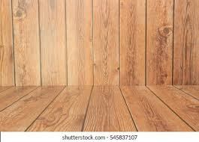

### Background

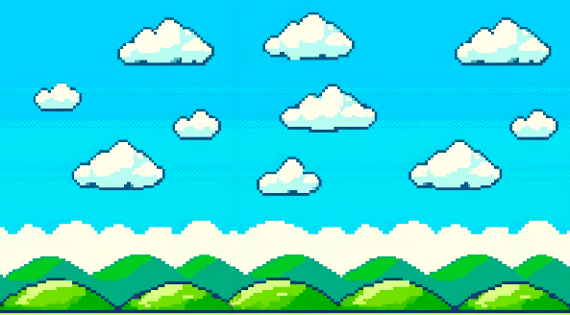

### Pipes

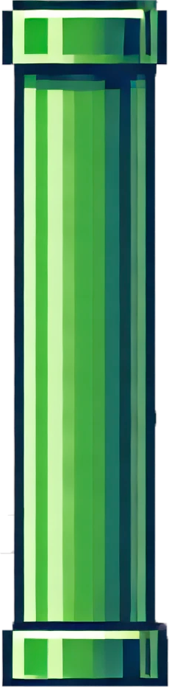

## Mock design screen

Score: 0

### Initial start screen: State 1

## 19,409 Bird Sheet Royalty-Free Images, Stock Photos & Pictures | ShutterstockCodédex | Build a Flappy Bird Clone With Phaser

Play

The play button will be pressed by the user to begin the game and the score has been set back to 0.

### State 2

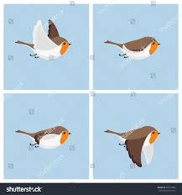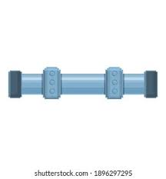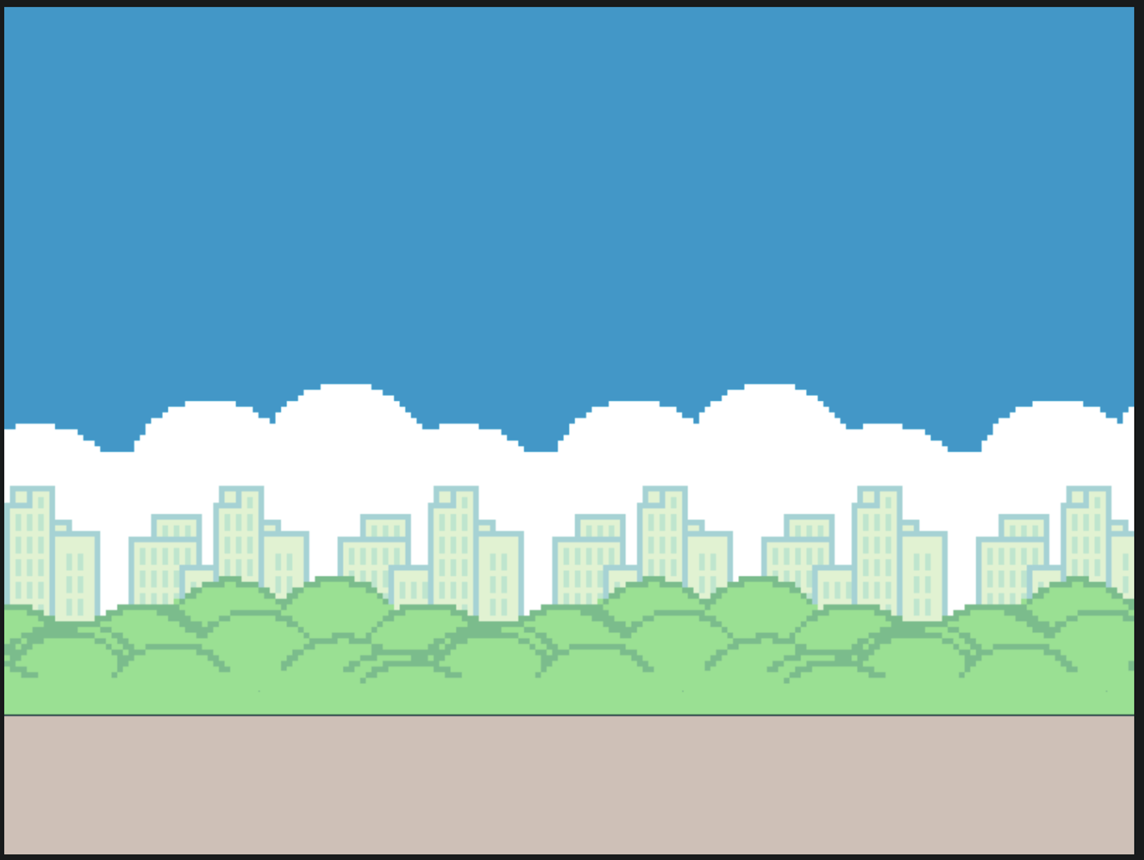

**Score : 3**

The play button is hidden and the score is indented as the bird passes through the barriers.

### State 3



Score : 15

Game over

Play

The play button will reappear on the screen and score that the player got would be showed at the top of the screen until the user presses the play again button where the game will progress back to state 1

## PsedoCode

### Player

Class Player:

Variable SpriteRenderer: SpriteRenderer

Variable sprites: Array of Sprite

Variable spriteIndex: Integer

Variable direction: Vector3

Variable gravity: Float = -9.8

Variable strength: Float = 5

Function Start:

Invoke "AnimateSprite" every 0.15 seconds, starting after 0.15 second

Function Awake:

Get the SpriteRenderer component of the object

Function Update:

If Space key or Mouse button is pressed: Set direction to move upwards (direction = Vector3.up *strength)

Apply gravity to direction.y (direction.y += gravity * Time.deltaTime)

Move the player by direction * Time.deltaTime (transform.position += direction * Time.deltaTime)

Function OnTriggerEnter2D(other):

If the collided object has tag "Pipes":

Call the GameOver function from the GameLoop

Else if the collided object has tag "Scoring":

Call the IncreaseScore function from the GameLoop

Function AnimateSprite:

Increment spriteIndex by 1

If spriteIndex exceeds or equals the length of the sprites array:

Reset spriteIndex to 0

Set the SpriteRenderer's sprite to the sprite at spriteIndex

### Spawner

Class Spawner:

Variables:

prefab (GameObject)

spawnrate (float) = 1.0

minheight (float) = -1.0

maxheight (float) = 1.0

Method OnEnable:

Call InvokeRepeating with Spawn method, spawnrate, spawnrate

Method OnDisable:

Call CancelInvoke with Spawn method

Method Spawn:

Create a new GameObject called pipes using prefab at the current position and no rotation

Randomly adjust the vertical position of pipes by multiplying the values of max height and min height to the pipes. This gives the pipes it’s random arrangement

### Pipes

Class Pipes:

Variables:

speed (float) = 1.0

leftEdge (float)

Method Start:

Set leftEdge to the x position of the left side of the screen minus 1

Method Update:

Move the object to the left by speed multiplied by deltaTime

If the object's x position is less than leftEdge:

Destroy the object

Else if deltaTime is 0:

Destroy the gameobject

### Game loop

Class GameLoop:

Variables:

player (Player)

score (int)

scoreText (Text)

playButton (GameObject)

gameOver (GameObject)

Method Awake:

Set target frame rate to 30

Set gameOver object to inactive

Call Pause method

Method Play:

Find the Player GameObject by name ("Player")

Set score to 0

Set Player's position to (0, 0, 10)

Update the scoreText to display the score (0)

Set playButton to inactive

Set gameOver to inactive

Set timeScale to 1 (game is running)

Method Pause:

Set TimeScale to 0 (pause the game)

Disable the player (pause player control)

Method GameOver:

Set GameOver object to active

Set PlayButton to active

Call Pause method

Method IncreaseScore:

Increment score by 1

Update ScoreText to display the new score

### Background

Class Parallex_BG:

Variables:

meshRenderer (MeshRenderer)

animationSpeed (float) = 1.0

Method Awake:

Get the MeshRenderer component attached to this object and store it in meshRenderer

Method Update:

Update the main texture offset of the material by animationSpeed multiplied by deltaTime on the x-axis

## Test Plan

|  |  |  |  |  |
| --- | --- | --- | --- | --- |
| What are we testing | Test number | Test Data | Expected Result | Observed result |
| The jump mechanic inputs | 00 | The inputted data value whether being the space bar or right click | The bird’s y level should increase after the input | The jump mechanic was planned correctly and worked however it was not initially enabled by the game loop |
| If you escape the screen | 01 | This will occur when the user has inputted the jump input too many times. | The bird should still die regardless due to the barriers still being present | The game problem was solved effectively by making the barriers at a much greater height than the screen. This served as a sufficient solution since the bird would still die if they had reached a great y level. |
| If you beat high score | 02 | There will be a text file that stores the high score | The score should be loaded as the game is loaded and it should be rendered into the corner of the screen as the game is loaded | The high score feature was never added so this is unable to be tested. If an update was to happen there will be a feature to store the highest score. The reason behind it not being added is because of the time constraints surrounding the project. |
| If you collide with barrier | 03 | The game should appear to be halted | A game over visual should be put onto the screen and the loop should be halted | This worked as expected. |
| If you collide with the floor | 04 | The game should appear to be halted | A game over visual should be put onto the screen and the loop should be halted | There was an initial issue however it was solved and address in the implementation section. |
| Restart (Respawn state) and the UI | 05 | There will be a button present on screen to start the game | When the play button is clicked the game loop will start or restart based on the previous state of the game |  |
| Scoring | 06 | There will be a counter that will increment based on its previous value and will be reset when the game loop ends | The counter should count indefinitely and the should be reset when the game loop has ended | The scoring counted continuously however after the game loop had ended the counter did not reset until further code was added. |
| Game Over | 07 | There will be a game state where this is true | The game will appear paused to be paused as the screen is shown | This worked as expected |
| If your score passed 99999999 what happens | 08 | The counter is variable incremented when the user passes through the barrier | The score should continue to increment and stay centred on the screen. | This worked as expected and was tested by setting the score initially in the code to a very large value and seeing how it would effect the program. There was no change to what was expected. |
| If buttons besides my specific input buttons are entered | 09 | Testing to see what happens when buttons that aren’t the scape bar or left click are clicked | Nothing should happen and the inputs should be ignored by the program | This worked as expected. |
| Test the terminal velocity | 10 | What happens when you keep pressing replay without inputting the jump input | The bird velocity should be reset to 0 before the acceleration is reapplied | There is no terminal velocity and the acceleration value of the bird before its death is carried over meaning the bird falls at a quicker rate than it should. This problem was not solved however if there was an update a cap would be set to the maximum value of the velocity of the bird. |
| The initial screen having a game over logo | 11 | How does the screen look when initially opened compared to when the first death has occurred. | At first the game over screen should be hidden only reappearing after the first death of the user | There was an of the GameOver logo being showcased initially before the game even being run. However, this was addressed and solved effectively. |
| Making sure the frame rate is capped for optimal performance in line with the stake holders | 12 | The frame rate should be maxed out at 30 FPS | The frame rate should be maxed at 30 FPS | The FPS of the game was initially uncapped. This was addressed in my implementation. |
| If the Pipes are deleted after the game has ended | 13 | Testing to see that when the state of the game is game over if the pipes from the previous round are deleted | The Pipes should be deleted after the start game loop has ended | The pipes weren’t deleted until the code was updated. |
| The barriers deletion | 14 | The barrier are supposed to move until they are off the screen then they should delete the object | The barrier should travel of the screen and be deleted once they are off the screen and no time before | The pipes after being spawned would deleted too early giving the illusion of them just disappearing however this issue was later solved |

# Implementation/ Development

## Game Objects

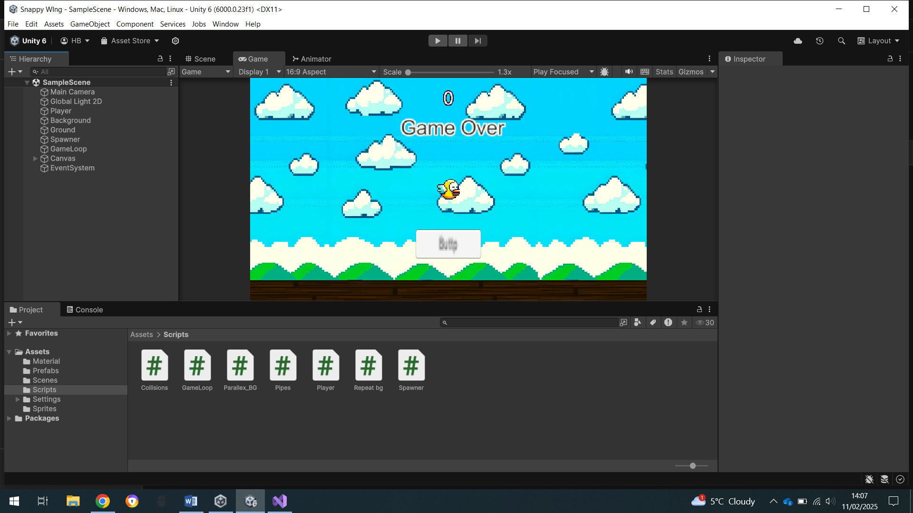

## Main Camera

### Purpose

The main camera is responsible for rendering the game world for a specific perspective allowing the game to be seen by the user and show the interactions between the objects. In this project the Main camera present the game in a 2D orthographic way from a side view. It would be an insufficient use of time to hard code a new camera since it would likely be done more inefficiently that the camera that Unity has provided.

### Key properties

The original transform X and Y are very important to ensure that the scene the game is properly present in the scene. The screen also won’t show hidden components on the screen to the user despite them still being present. It is important that its x and y position are set to 0 so when the bird object is created it can be correctly shown on the screen and in-frame. In addition, it is important to set the z to -10 so that when the screen is drawn with the background and pipes it catches all the components and objects related to the game in the correct order. If the z was a greater number than negative 10 it would mean that when the screen is drawn any objects modelled at a z value than the screen would be missed. This could serve as an issue and would defeat the purpose of the game since the user may not be able to see the characters they are controlling or the obstacles they are trying to avoid.

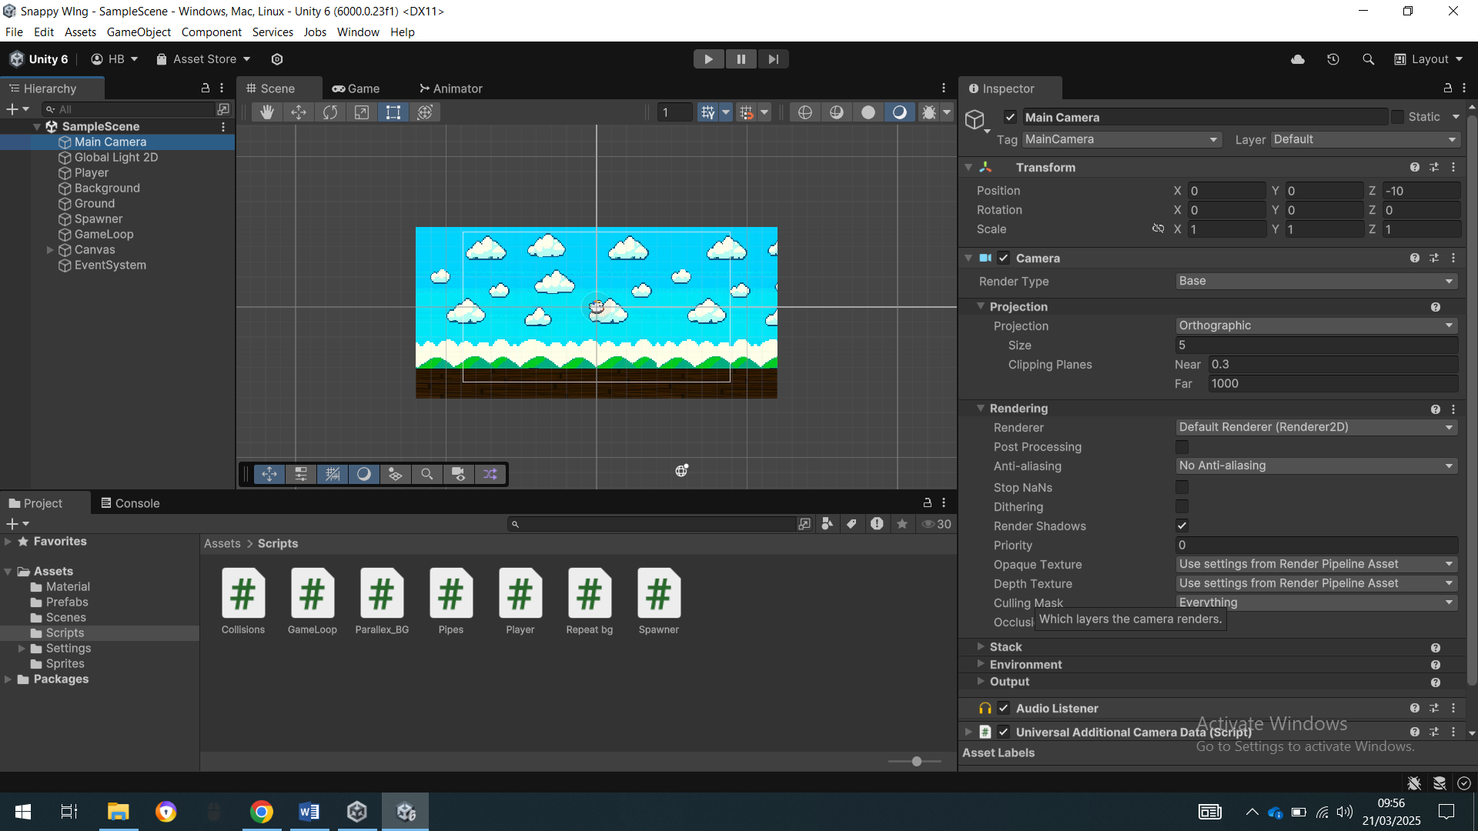

### Problems I ran into

I ran into an issue regarding the layers that the game drew the screen as since I was unaware of the how smaller x values mean that the object was further away it meant that my screen was drawn incorrectly at first and despite the object being created it was not visible on the screen.

## Main menu

### Purpose

The main menu serves as an interactive UI with a button that make the game interactive. There is a button that changes the state of the game putting it into the Play state. I decided to make it a button due to buttons being used as the de-facto means of starting a game.

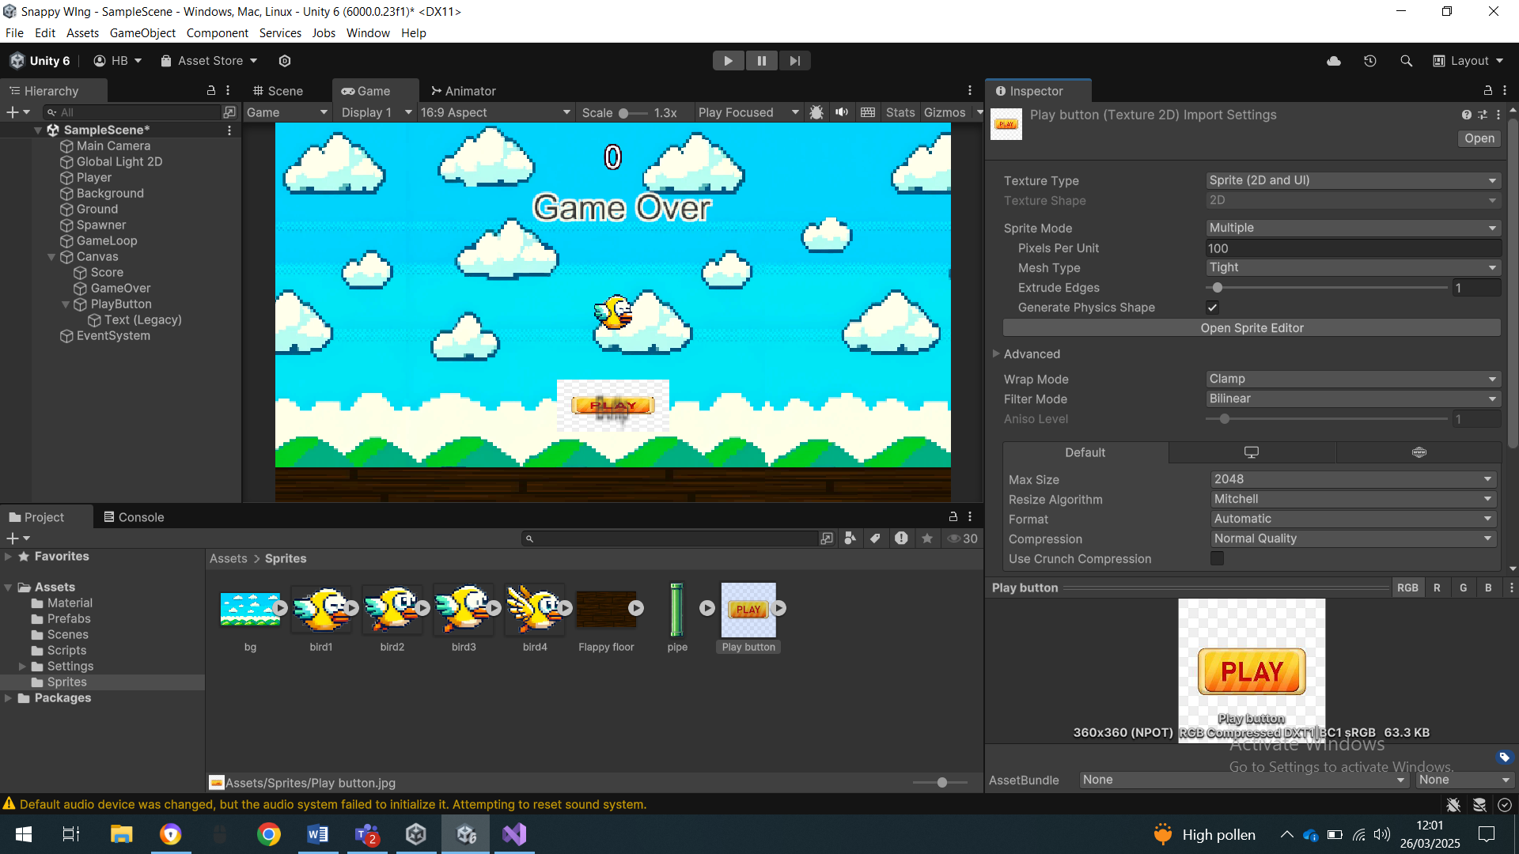

### A problem I ran into

A problem I ran into was the game over screen being showed initially immediately when the code was run. This served to a logic error since the game hadn’t even begun for it to be open relating to my test 11. This would be a problem to my stakeholders because it would be claiming that they have died before they have even started. I solved this by disabling the game over object initially when the game is freshly opened up meaning that at first the game over screen isn’t showing solving the problem previously observed aligning with my test data expected result.

## Player

### Purpose

The player object is the physical entity that the user is able to control and manipulate within the laws of the game. The object will consist of scripts and various visual elements like the sprite and flapping elements. The inputs would be directly applied to the object. I have done this because I have previously mentioned that would be a feature in the analysis and the design.

### Key properties

The player object contains the transform component with X, Y and Z which is important since it values will change depending on the input or lack of input by the user. Initially its transform values will be x:0 y:0 z:10. I have made this the case so the bird will be in the frame from the very beginning of the frame this is so the user will be able to see the position of the bird meaning that when the start method is called in the game loop class the bird will be in the optimal position to evade the barriers. In addition, the reason for the Z to be 10 was to make sure that the bird will be drawn onto the screen in the correct order so it can be viewed by the Main Camera.

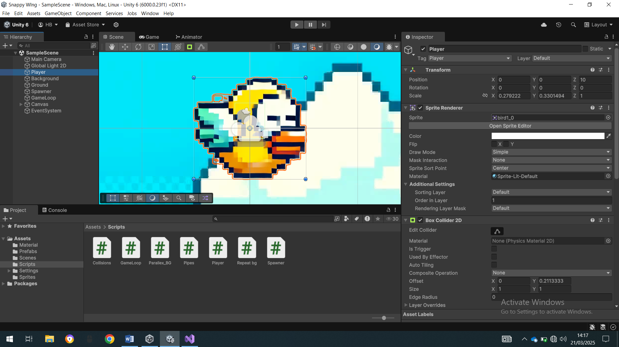

### Problems I ran into

An issue I had at first was making the Z value a smaller negative value than the Main Camera. As a result of this the bird was drawn after the layer that the screen was viewing. This was made right after testing the value when the z was -100 compared to what I settled with at 10. This also aligns with the game that the stake holders would want in terms of the games’ design.

### Another key property

The input management system is key to make sure the sprite is able to be controlled by the user. If the space bar or the left click was pressed there would be an acceleration to the bird

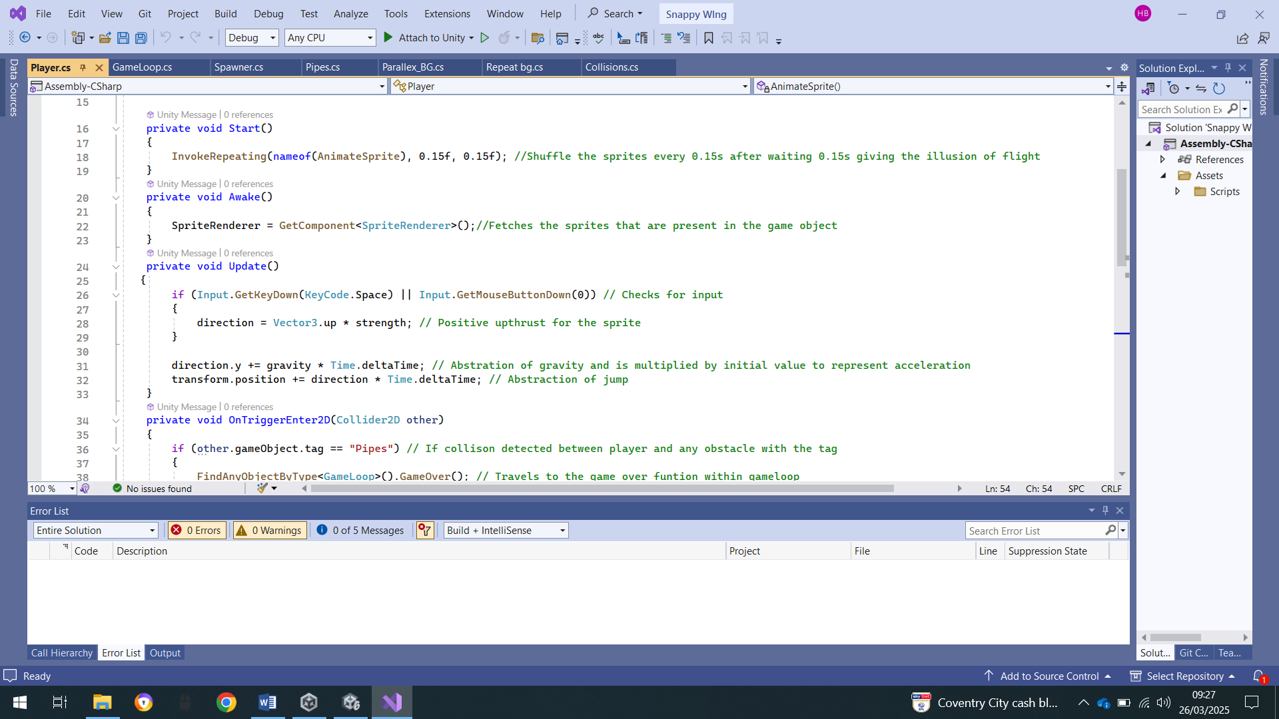

### Problems I ran into

I tested what would happen if inputs that were unrelated to the code were inputted and found that nothing happened meaning that the code was robust enough to not break when things like that happen. My expected result that was mentioned in Test 09 was observed. The reason the code was made to be robust was because if an input outside of the allotted inputs specified was entered the game ignores the input and continues in its current state

### Another key feature

### The collision detection feature to ensure that the game loop is halted after a collision between the player and a barrier.

### 

### A problem I ran into

When the game was tested the game loop would end when the bird collided with the pipes however when there was a collision between the bird and the ground nothing would happen leading to the game not being robust and the game unplayable. There were two issues that needed to be solved. The first was ensuring that the z level of both the sprite and the barrier were set to the same level. The reason this served as an issue was because despite the two objects seeming to be in contact due to the x and y positions of the particles being the same in actual fact they were not actually in contact since the z values were different. To solve this, I ensured that the position of both the barriers and obstacles had a z level which was the same value as the player object. In addition, another problem I ran into was having the ground tagged as pipes since the loop only accounts for objects tagged as pipes meaning that without the tag the will be no selection that occurs meaning the sprite would just pass through. However, I solved this by tagging the ground also as pipes. It would have been more suitable if I had made that tag to be called obstacles rather than pipes but I think my code’s documentation makes it clear to understand the process. This addresses my test 03 and test 04

### Another essential feature

An essential feature is the process of loop through the sprites giving the perception of animated flight

private void Start()

{

InvokeRepeating(nameof(AnimateSprite), 0.15f, 0.15f); //Shuffle the sprites every 0.15s after waiting 0.15s giving the illusion of flight

}

private void AnimateSprite()

{

// Increment the sprite index to switch to the next sprite in the sequence

spriteIndex++;

// Check if the index has reached or exceeded the length of the sprites array

if (spriteIndex >= sprites.Length)

{

// If so, reset the spriteIndex back to 0 to loop the animation

spriteIndex = 0;

}

// Update the SpriteRenderer's sprite to the new sprite based on the current spriteIndex

SpriteRenderer.sprite = sprites[spriteIndex];

}

## Game loop

### Purpose

The game loop is the script of the program responsible for managing the states of the game whether it is the start state the paused state or the progression states.

### Key properties

The start of the game is very important since

private void Awake()

{

// Sets the target frame rate to 30 FPS

Application.targetFrameRate = 30;

// Hides the game over screen initially

gameOver.SetActive(false);

// Pauses the game when the scene starts

Pause();

}

public void Pause()

{

// Freezes time by setting time scale to 0

Time.timeScale = 0f;

// Disables the player controls (player script)

player.enabled = false;

}

A problem I ran into at first was that the games Frame rate was uncapped causing the game frame rate to work at the rate suitable to the computer. This for many computers wouldn’t have been an issue but it fell outside what was required by my stake holders which mentioned that they may want the game to be played on devices not purposely built for games such as school computers and other like it. My solution to this was to make sure that the applications frame rate had a cap at 30FPS because the game is so simple the frame rate cap won’t affect the games performance due to it being simple in nature with only a limited number of moving components at a time, the cap allows the game to perform better for devices with lower specifications. This in turn made the game’s frame follow what was expected and mentioned in the test table. Test 12.

### Another key Feature

Another key feature is the Play method. This begins the game loop and enables the parts of the program to operate. I made the game like this to ensure that the game is always in a clear state where its processes are easily discernible. I made the game like this to reduce confusion for my end users.

public void Play()

{

// Finds the Player GameObject in the scene

GameObject Sprite = GameObject.Find("Player"); // Note: GameObject.Find() can be slow and should be avoided when possible

// Resets the score to 0 at the start of a new game

score = 0;

// Resets the player's position to the start location (0, 0, 10)

Sprite.GetComponent<Transform>().position = new Vector3(0F, 0F, 10f);

// Updates the score text UI

scoreText.text = score.ToString();

// Hides the play button and game over screen

playButton.SetActive(false);

gameOver.SetActive(false);

// Resumes game time (time scale set to 1)

Time.timeScale = 1f;

### A problem I ran into

I ran into a problem with the pipes not deleting immediately after the game loop had ended leading the game to crash and or be unplayable for the next round. This was because despite the birds position being reset the scene was still full of the previously instantiated pipes leading to the bird to die again instantly. My initial ineffective solution to the problem was presented in the code below.

/*Pipes[] pipes = FindObjectOfType<Pipes>();

for (int i = 0; i < pipes.Length; i++)

{

Destroy(pipes[i]

.gameObject);

}*/

My thought process behind it being that the pipes instantiated in the spawner would be in an array and the algorithm would loop through the array deleting the pipes as it found them in the array until there weren’t any new elements. The process behind the code seems logical and plausible however I think that I wasn’t able to implement it correctly. My final solution was shown the code below in my pipes script shown below.

else if (Time.deltaTime == 0)

{

// If Time.deltaTime is 0 (which can happen in certain situations, like when the game is paused), destroy the object

Destroy(gameObject);

}

Since my solution to pausing the game after the game loop had finished running was to set the time to 0 and the timescale to 0. The code above meant that when the game time had been set to 0 all pipes game objects are deleted. This served as a heuristic solution to my code despite it not being the most efficient solution it will do the job and delete all aspects that need to be deleted before the next game cycle or the game is restarted.

### Another essential feature

Another essential feature was ensuring that the game’s score was incremented through the progression. The score would be updated every time a collision between the invisible barrier and the bird occurred with the outcome being the score updated by one

public void IncreaseScore()

{

// Increments the score by 1

score++;

// Updates the score text UI to reflect the new score

scoreText.text = score.ToString();

}

### Problems I ran into

The score of the player that had just played wouldn’t be cleared. This resulted in the scores carrying over to the next game cycle. This goes against what my stakeholders would have wanted and wouldn’t be the expected outcome states in test 06. This is because my outcome stated that the score should reset when the game loop ends. The reason behind this was to make the games all independent to each other and meet the criteria.

My solution to this is stated in the code below.

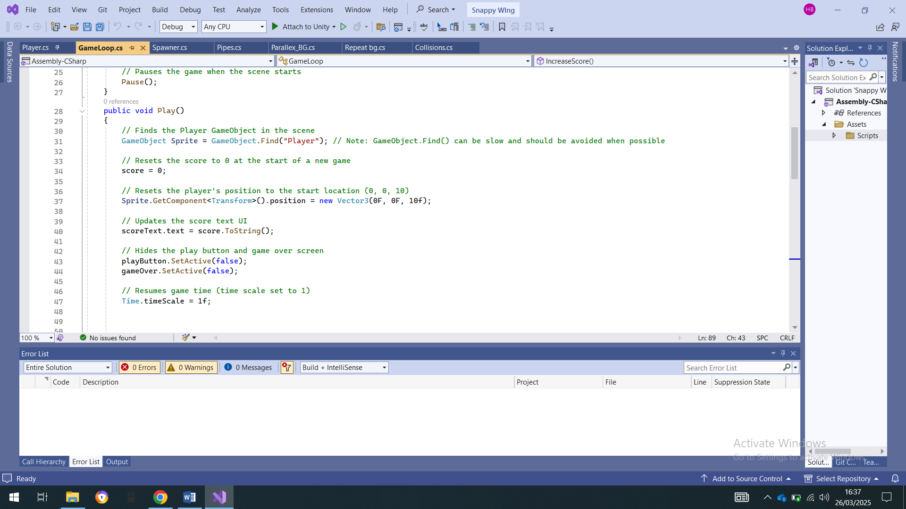

This highlighted code ensures that when the play button is pressed regardless of the previous value of the high score the score will be made back to 0 following the expected outcome of test 06.

### Another issue I ran into

When trying to make improvements to my code I ran into an issue of the bird seeming to be frozen into place at the origin of the screen. This served as an issue because despite the barriers and the game loop being run the player would be unable to avoid the obstacles presented leading to a game that isn’t functional and correctly designed. Through review I realised that the player script wasn’t enabled in the game loop meaning that the gravity method, controls and all methods of the bird weren’t enabled meaning it didn’t run correctly. My solution to this was to add the code shown below in the play method in GameLoop. This aligns with the expected data in test 00

player.enabled = true;

## Spawner

### Purpose

The purpose of the spawner is to instantiate objects of the pipes class repeatedly, at varied heights. I decided to make the algorithm like this in a cast compositional way as it would be different to the method I would usually take and just as effective. An alternate solution to the way I have chosen would be to have made 5 pipes present and have them loop through the screen and once off the screen having them loop back to the beginning of the screen. This would be good since it would make it easier if the barriers had different properties however in a game like this where the barrier are all the same it would be useful in addition to the fact that more calculations would be required to making sure the barriers move when they are off the visible screen to right before the screen. It would also be harder to vary the heights of already instantiated pipes so the gaps between them are still the same. Overall I think have the barriers and instantiated and deleted serves as a better solution since they can be spawned in at the desired height and deleted effectively. A downside may be that if the program is run for too long more memory will be used during the instantiation process but the solution would be neater and the program will not be run for long enough for that to serve as an issue.

### Key feature

The spawner really only has one feature that being to spawn the pipes at the same interval at different heights but a width between them that remains consistent.

public class Spawner : MonoBehaviour

{

// Reference to the GameObject prefab that will be instantiated.

public GameObject prefab;

// Time interval (in seconds) between spawns.

public float spawnrate = 1f;

// Minimum vertical offset (in world space) for the spawned object.

public float minheight = -1f;

// Maximum vertical offset (in world space) for the spawned object.

public float maxheight = 1f;

// Called when the object becomes enabled and active.

private void OnEnable()

{

// Repeatedly call the Spawn method at intervals defined by spawnrate.

InvokeRepeating(nameof(Spawn), spawnrate, spawnrate);

}

// Called when the object is disabled.

private void OnDisable()

{

// Stop invoking the Spawn method when the object is disabled.

CancelInvoke(nameof(Spawn));

}

// This method handles the actual spawning of the prefab object.

private void Spawn()

{

// Instantiate the prefab at the position of this GameObject with no rotation (Quaternion.identity).

GameObject pipes = Instantiate(prefab, transform.position, Quaternion.identity);

// Add a random vertical offset (between minheight and maxheight) to the instantiated object.

pipes.transform.position += Vector3.up * Random.Range(minheight, maxheight);

}

}

## Pipes

### Purpose

The pipes are the objects that are avoided by the player to serve as obstacles that the player has to avoid. They will travel from the left side of the screen to the right side and be deleted once off the screen. I could have made the barrier travel from the right to the left but that may be uncomfortable for the stakeholders and outside the allotted rules in my analysis of the problem

### Key feature

A key feature of the game is get the most left position if the screen and store it so it can be referenced and called upon again. The code to do it is shown below.

private void Start()

{

// Calculate the position of the left edge of the screen in world space

// Camera.main.ScreenToWorldPoint(Vector3.zero) gives the world position of the bottom-left corner of the screen

// Subtracting 1f ensures the object moves off the screen just before disappearing

leftEdge = Camera.main.ScreenToWorldPoint(Vector3.zero).x - 1f;

}

### Another key feature

There is a feature controlling the pipes movement after being instantiated based on the initial position of the object being then transformed by a vector distance based on the time elapsed.

private void Update()

{

// Move the object to the left every frame by a certain amount, determined by the speed

// Vector3.left is a shorthand for the vector (-1, 0, 0) which represents leftward movement

// Time.deltaTime ensures the movement is frame-rate independent (i.e., consistent across different frame rates)

transform.position += Vector3.left * speed * Time.deltaTime;

// Check if the object has moved past the left edge of the screen

if (transform.position.x < leftEdge)

{

// If the object has moved past the left edge, destroy it

Destroy(gameObject);

}

else if (Time.deltaTime == 0)

{

// If Time.deltaTime is 0 (which can happen in certain situations, like when the game is paused), destroy the object

Destroy(gameObject);

}

}

}

### A problem I ran into

When I made the algorithm the process of them travelling to the end and deleting worked pretty well however like referenced in test 13 was that the pipes would delete before completely making their way off the screen. This solution would not affect the programs usability but it would serve as a logical defect and would not align with the views of my stakeholders. To solve this problem and make it more like the expected outcome of the test 13 I moved the left edge variable one frame to the left. This would mean that the pipes deletion would be perceived to be deleted slightly later after they have completely left the screen shown in the code below.

leftEdge = Camera.main.ScreenToWorldPoint(Vector3.zero).x - 1f;

### Parallex_bg

### Purpose

The purpose of the Parallex bg is to ensure that the bird appears to be moving due to the movement via the screens movement.

The code to do that is shown below.

public class Parallex_BG : MonoBehaviour

{

// Private variable to store the reference to the MeshRenderer component

private MeshRenderer meshRenderer;

// Public variable to control the animation speed of the background

public float animationSpeed = 1;

// Awake is called when the script instance is being loaded (before Start)

private void Awake()

{

// Get the MeshRenderer component attached to the GameObject

meshRenderer = GetComponent<MeshRenderer>();

}

private void Update()

{

// Updates the texture offset on the material to animate the background

// The texture moves along the x-axis based on the animationSpeed and the frame's delta time

meshRenderer.material.mainTextureOffset += new Vector2(animationSpeed * Time.deltaTime, 0);

}

}

At first I tried to make the manage the background by having 2 separate screens that are pixelated and aligning them side by side to then as then loop around each other as the game went on. The screen would travel the perfectly to the end of the next slide giving the illusion of a perfectly flowing screen. However, I believe the logic behind the initial plan was correct however I was unable to implement It effectively as shown below.

public class Repeatbg : MonoBehaviour

{

private BoxCollider2D bc;

private Rigidbody2D rb;

private float width;

public float speed = -2f;

void Start()

{

bc = GetComponent<BoxCollider2D>();

rb = GetComponent<Rigidbody2D>();

width = bc.size.x;

rb.linearVelocity = new Vector2(speed, 0);

}

// Update is called once per frame

void Update()

{

if (transform.position.x < -width)

{

Reposition();

}

}

private void Reposition()

{

Vector2 vector = new Vector2(width*2f,0);

transform.position = (Vector2)transform.position + vector;

}

}

Therefore, to get the desired outcome to align with my stakeholders I settled with the solution I showed first. Since the screen will move effectively as intended and less memory would be required since there will be only image in play.

# All code

### Player Script

using Unity.VisualScripting;

using UnityEngine;

public class Player : MonoBehaviour

{

private SpriteRenderer SpriteRenderer;

public Sprite[] sprites;

private int spriteIndex;

private Vector3 direction;

public float gravity = -9.8f;

public float strength = 5f;

private void Start()

{

InvokeRepeating(nameof(AnimateSprite), 0.15f, 0.15f); //Shuffle the sprites every 0.15s after waiting 0.15s giving the illusion of flight

}

private void Awake()

{

SpriteRenderer = GetComponent<SpriteRenderer>();//Fetches the sprites that are present in the game object

}

private void Update()

{

if (Input.GetKeyDown(KeyCode.Space) || Input.GetMouseButtonDown(0)) // Checks for input

{

direction = Vector3.up * strength; // Positive upthrust for the sprite

}

direction.y += gravity * Time.deltaTime; // Abstration of gravity and is multiplied by initial value to represent acceleration

transform.position += direction * Time.deltaTime; // Abstraction of jump

}

private void OnTriggerEnter2D(Collider2D other)

{

if (other.gameObject.tag == "Pipes") // If collison detected between player and any obstacle with the tag

{

FindAnyObjectByType<GameLoop>().GameOver(); // Travels to the game over funtion within gameloop

}

else if (other.gameObject.tag == "Scoring") // If collision detacted with the invisble barrier or other things with the tag

{

FindAnyObjectByType<GameLoop>().IncreaseScore(); // Travels to the increase score function within the gameloop

}

}

private void AnimateSprite()

{

// Increment the sprite index to move to the next sprite

spriteIndex++;

// Check if the index has exceeded the bounds of the sprite array

if (spriteIndex >= sprites.Length)

{

// If the index is beyond the array length, reset it to 0 to loop back to the first sprite

spriteIndex = 0;

}

// Update the sprite on the SpriteRenderer component to display the current sprite

SpriteRenderer.sprite = sprites[spriteIndex];

}

}

### Game loop Script

using System;

using UnityEngine;

using UnityEngine.UI;

public class GameLoop : MonoBehaviour

{

// Public variables to allow setting from the Unity Editor

public Player player; // Reference to the Player object

private int score; // Holds the current score

public Text scoreText; // UI Text component to display the score

public GameObject playButton; // Reference to the Play button object in the UI

public GameObject gameOver; // Reference to the GameOver screen object in the UI

private void Awake()

{

// Sets the target frame rate to 30 FPS

Application.targetFrameRate = 30;

// Hides the game over screen initially

gameOver.SetActive(false);

// Pauses the game when the scene starts

Pause();

}

public void Play()

{

// Finds the Player GameObject in the scene

GameObject Sprite = GameObject.Find("Player"); // Note: GameObject.Find() can be slow and should be avoided when possible

// Resets the score to 0 at the start of a new game

score = 0;

// Resets the player's position to the start location (0, 0, 10)

Sprite.GetComponent<Transform>().position = new Vector3(0F, 0F, 10f);

// Updates the score text UI

scoreText.text = score.ToString();

// Hides the play button and game over screen

playButton.SetActive(false);

gameOver.SetActive(false);

// Resumes game time (time scale set to 1)

Time.timeScale = 1f;

/*Pipes[] pipes = FindObjectOfType<Pipes>();

for (int i = 0; i < pipes.Length; i++)

{

Destroy(pipes[i].gameObject);

}*/

}

public void Pause()

{

// Freezes time by setting time scale to 0

Time.timeScale = 0f;

// Disables the player controls (player script)

player.enabled = false;

}

public void GameOver()

{

// Activates the game over screen

gameOver.SetActive(true);

// Displays the play button to allow the player to restart

playButton.SetActive(true);

// Pauses the game

Pause();

}

public void IncreaseScore()

{

// Increments the score by 1

score++;

// Updates the score text UI to reflect the new score

scoreText.text = score.ToString();

}

}

### Parallax_Bg

using UnityEngine;

public class Parallex_BG : MonoBehaviour

{

// Private variable to store the reference to the MeshRenderer component

private MeshRenderer meshRenderer;

// Public variable to control the animation speed of the background

public float animationSpeed = 1;

// Awake is called when the script instance is being loaded (before Start)

private void Awake()

{

// Get the MeshRenderer component attached to the GameObject

meshRenderer = GetComponent<MeshRenderer>();

}

private void Update()

{

// Updates the texture offset on the material to animate the background

// The texture moves along the x-axis based on the animationSpeed and the frame's delta time

meshRenderer.material.mainTextureOffset += new Vector2(animationSpeed * Time.deltaTime, 0);

}

}

### Pipes

using UnityEngine;

using UnityEngine.SceneManagement;

using UnityEngine.SocialPlatforms;

public class Pipes : MonoBehaviour

{

// Public variable to control the speed of the object’s movement

public float speed = 1.0f;

// Private variable to store the x-coordinate of the left edge of the screen

private float leftEdge;

// Start is called before the first frame update

private void Start()

{

// Calculate the position of the left edge of the screen in world space

// Camera.main.ScreenToWorldPoint(Vector3.zero) gives the world position of the bottom-left corner of the screen

// Subtracting 1f ensures the object moves off the screen just before disappearing

leftEdge = Camera.main.ScreenToWorldPoint(Vector3.zero).x - 1f;

}

// Update is called once per frame

private void Update()

{

// Move the object to the left every frame by a certain amount, determined by the speed

// Vector3.left is a shorthand for the vector (-1, 0, 0) which represents leftward movement

// Time.deltaTime ensures the movement is frame-rate independent (i.e., consistent across different frame rates)

transform.position += Vector3.left * speed * Time.deltaTime;

// Check if the object has moved past the left edge of the screen

if (transform.position.x < leftEdge)

{

// If the object has moved past the left edge, destroy it

Destroy(gameObject);

}

else if (Time.deltaTime == 0)

{

// If Time.deltaTime is 0 (which can happen in certain situations, like when the game is paused), destroy the object

Destroy(gameObject);

}

}

}

### Spawner

using UnityEngine;

public class Spawner : MonoBehaviour

{

// Reference to the GameObject prefab that will be instantiated.

public GameObject prefab;

// Time interval (in seconds) between spawns.

public float spawnrate = 1f;

// Minimum vertical offset (in world space) for the spawned object.

public float minheight = -1f;

// Maximum vertical offset (in world space) for the spawned object.

public float maxheight = 1f;

// Called when the object becomes enabled and active.

private void OnEnable()

{

// Repeatedly call the Spawn method at intervals defined by spawnrate.

InvokeRepeating(nameof(Spawn), spawnrate, spawnrate);

}

// Called when the object is disabled.

private void OnDisable()

{

// Stop invoking the Spawn method when the object is disabled.

CancelInvoke(nameof(Spawn));

}

// This method handles the actual spawning of the prefab object.

private void Spawn()

{

// Instantiate the prefab at the position of this GameObject with no rotation (Quaternion.identity).

GameObject pipes = Instantiate(prefab, transform.position, Quaternion.identity);

// Add a random vertical offset (between minheight and maxheight) to the instantiated object.

pipes.transform.position += Vector3.up * Random.Range(minheight, maxheight);

}

}

Game test: [Snappy Wing test.mp4](https://campionsignon-my.sharepoint.com/:v:/g/personal/hboris18_thecampionschool_org_uk/EZmEzJOvnBRGk6BPVh5_hl4BU89W3h_ikN0HPFVwji_BmA?e=18Rqzi)

# Evaluation

## Review of Success Criteria

### Review success criteria 3

My 3rd success criteria states that the game has a clear process and clearly defined states with the barriers and ground moving. I believe I was able to successfully implement the game mechanism of the barriers moving linearly and was able to add sufficient difficulty on the locations of the pipes in contrast to its previous pipe. A way that the game is lacking is that some of the distances between the pipes are unachievable making the game too hard dependant on luck rather than the skill of the player. My stakeholders wanted the game to be made more challenging and different to previous games made before meaning the fact that the game is based heavily on luck is not a desirable outcome since it doesn’t align completely with my stakeholders. A better solution would be to have calculated the most extreme cases that the values that the sprite could have been in and plan the values of its height and position accordingly. Overall I would say that the criteria were sufficiently met because despite the game having some impossible scenarios the likelihood of these cases being reached are low meaning that the game has a lot of cases where skill is required which was desired by my stakeholder.

In addition, the idea of having clear stages and progression is fundamental to my game to allow the user to understand what their goal is at any specific time frame. This also allows the user to prepare themselves for what is happening next as it allows the game to have a flow and have a sense of structure which was desired by my end users.

Overall I think that the success criteria 3 was answers sufficiently and if given further time or allowed to make updates to the, I would ensure that the pipes distances were always evenly spaced out and achievable for the bird based on its previous locations.

### Review success criteria 1

The game has been made sufficiently robust and I have addressed the cases of the bird flying outside of the screen by making the obstacles span further outside the screen that what is visible to the user. This solved the problem since the game loop would end if the player was outside the screen for too long. In addition, due to the game not having any unreasonable means of ending there will be a wider appeal improving the games success since it will account for in experienced users that may not be as adept in playing the game as they may not initially understand the game but they will pick up with trials. This is some important criteria, especially because it addresses **quality assurance**, which is crucial for any game. If the game isn't stable or reliable, even the best game mechanics and design elements will be undermined. Ensuring that the game is **robust** and **error-free** is particularly important if you want to guarantee positive feedback and good reviews from my stakeholders.

Overall I believe this success criteria were sufficiently addressed and the fact that the game was created in a robust manor making the game easily playable for all audiences even outside my stakeholders. This means the success criteria was reached.

### Review success criteria 4

My success criteria 4 mentioned the design criteria that I expected to be incorporated into the program. I was able to create screens scenes in suitable colours that avoided clashes and clearly differentiated the background elements and other components of the program. However, I did not include the aspect of the game that made the scenes or the players sprite customisable. This was mentioned in my game’s criteria as it would have accounted for stakeholders that may have some form of colour blindness and would have improved the usability of the program. This would have made the solution to my project better however I do not believe that the final product would be to negatively affected by the removal of the aspect.

Overall I believe that the criteria were partly reached since despite there being a set scene where the colours are clearly differentiated the lack of variety or ability to change serves the object colours and scene. The final solution was still sufficient for the game.

### Review success criteria 5

My success criteria 5 talked about the implementation of components to the game that would change the values of the gravity perhaps increasing the gravity acceleration or even adapting the change of the power of the upwards force that the bird is able to provide on user input. The user input and gravity all work just fine at the fixed scale however there was little addition to a feature that would change the value of the acceleration of the bird or other components of the game. Although all of these values can be edited outside of the game in the code however this does not correlate to how the desire outcome was perceived. I understand that this may be a let-down to some of the stakeholder that would have wanted a more challenging game however due to some of the difficult scenarios based on the pipe positioning they should find them with more than enough of a challenge. If the game was to face more iterative development or have updates there will certainly be the addition of power ups that would alter the gravity applied on the bird, the force the bird is able to exert and also alter the speed the barriers move towards the bird both making it faster and slower.

Overall I believe that the criteria were not met in full since despite the program having unbuilt natural speeds of processes once inside the game loop there is no way of changing its values without restarting the code. This means the stakeholders wish was not fully met and if updates were to made the addition of power ups would certainly be involved.

### Review success criteria 2

Success criteria 2 talked about making sure the amount of memory required is managed for the game to be suitable to be played on a range of different devices. To be more specific managing the frame rate of the game and the number of separate entities that the memory need to record and process at one time. Throughout the program I believe I effectively managed the amount of the components that would be in the frame one example being making the two looping screens one screen that is offset by some code in addition to having a maximum frame rate that the game can be run at helped satisfy the success criteria 4.

Overall I believe that success criteria 4 was solved pretty effectively and satisfies all the wants of the stakeholders. It could have been solved more effectively if I had managed to figure out a way to reduce the pixel colour depth required for drawing all the images and sprites to reduce memory required however that would have clashed with one of my other success criteria so this wouldn’t have been entirely possible.

### Features that would be added in the next update

Having the coin in-between the barrier disappear after collection would be an addition I would be sure to add since it would make the game seem more logically accurate since it would give the feel of a collection mechanism. This should have been added because it will make the users feel as though the game has a better aim that is clear and achievable. Without this feature the game may feel aimless to the user and devout of direction

### How maintainable is my code?

When it comes to writing maintainable code, I've focused on creating a structure that is easy to read, modify, and extend. One of the main principles I followed is **clear commenting** all throughout. During the creation of my project, I've made sure to provide meaningful comments that describe the purpose of various methods attributed and variables that I have used. This ensures that anyone who looks at the code including myself, when I come back after some time away can quickly understand what’s going on and why certain decisions were made. This has made my development significantly easier and allowed me to always understand exactly what I have done previously and help me manage my targets for what is still left to do. This can evidently be seen through all my code which has comments tagged out explaining exactly what it all does. In addition, the **overall structure** of the code is also something I focused on. I ensured that the project is organized into logical sections based on what the code is related to. This can be seen clearly by the fact all classes are present in their own c* file and all of its data relating to it is made private within the class unless the circumstances provide for the data to made public. This organization makes it easy to follow the flow of the program and simplifies any future updates or feature additions. It's clear where each section of functionality lives, and that structure will help when I begin to update the game later on.

## Post game development testing

Stakeholder named Jeremy:

**Interviewer:** Thank you for joining us today to discuss Snappy Wing. Let’s start by hearing your thoughts on the created game so far. What makes it so appealing for you?

**Jeremy:** Snappy Wing is a simple yet incredibly addictive game. The concept is very simple you control a bird that flaps its wings to avoid obstacles. I think for me the appeal comes from the fact that it’s easy to pick up but hard to master. The challenge of surviving through narrow gaps is part of what makes it so frustratingly fun. There’s something so satisfying about that retro pixelated look, too. It feels nostalgic.

**Interviewer:** That’s great to hear. We know that you also have some ideas for improving it. What kind of improvements do you think could be made to the game to enhance the experience, while keeping its original appeal intact?

**Stakeholder:** While Snappy Wing is a great game as it is, I think there are a few tweaks that could make it even more engaging and accessible for a wider range of players. In some instances, the barriers aren’t always in achievable locations making the game feel impossible at times or solely based on luck so **making the barriers always achievable** even if it means making the game a bit easier may be beneficial. The difficulty is one of the things that makes the game addictive, but it can also be a bit frustrating for new players or for those who aren't experienced gamers. Allowing players to have a better chance of getting through those pipes could make the game more enjoyable without taking away that sense of challenge. Maybe adding an option to choose the difficulty level could be a nice touch some players want a challenge, and others just want to relax and play.

**Interviewer:** That sounds like a thoughtful approach. What about introducing new elements like power-ups or changes to the core gameplay? Do you think there’s room for that in Flappy Bird?

**Stakeholder:** I think adding power-ups would open up a lot of interesting possibilities. For example, a shield power-up could give the bird a one-time protection from colliding with pipes. Or a slow-motion power-up could momentarily slow down the game, giving players a bit more time to react. These kinds of power-ups could add a fun, strategic layer to the gameplay. It would make the game feel a bit fresher and more exciting, while also giving players a chance to recover from tough spots. Another idea I had is to introduce random air currents. These would be like invisible forces that randomly sway the bird’s movement, making it harder for players to control the bird as it’s pushed up or down. It’s something outside of the player’s control, adding an element of unpredictability that could keep the gameplay exciting and dynamic.

**Interviewer:** I love that! The idea of unpredictability could certainly make the game feel less repetitive. How about the obstacles themselves? Do you think there’s room for more variety in terms of challenges?

**Stakeholder:** Definitely! The pipes are iconic, but **other flying bird moving in the opposite direction can serve as obstacles**. The pipes are a bit static, and while they get the job done, I think the addition of other flying creatures could add more diversity to the challenges. It would make the game feel a bit less predictable and give players more to think about. The combination of stationary and moving obstacles could make for a more dynamic challenge.

**Stakeholder:** Thank you! It’s been a pleasure talking about one of my favourite mobile games. I think with just a few tweaks; Snappy Wing could remain a favourite for years to come.

### Evaluation on Usability

Overall the final game is very usable since it has many desired feature as mentioned in my analysis of the problem implemented. As previously stated the game is monitored by a keyboard and mouse meaning that all personal set ups would be able to enjoy the game since it has been adapted to do so. In relation to the eye logger I mentioned in the analysis, though this would have been a great addition to the game’s usability it would have been difficult to implement and maintain and I would have more extensive skills in order to make this addition. This spans outside of the initial thought out scope. In addition to this not many people have an eye logger on their set up so it would be a large amount of work for a small return. Therefore, overall I believe it was perfectly reasonable to leave it out.

I have also added the score system in the middle of the screen mentioned in my design for a clear and easy viewing and I made the backgrounds different colours to avoid confusion by players and allow the player to know exactly what and who they are controlling. Despite the additional time required to design all the components it was an investment that aligned with the wants of my stakeholders.

A feature that would have made the game more usable was having an AI review how the game was played and suggest improvements that the user can listen to in order to improve their gameplay for later attempts. This feature would have been useful but there would be numerous steps in order to get this into place like getting an AI API which could result in me paying some monthly subscription in addition the method and time required to train the AI to understand its role and help it give correct analysis of game would be outside of the scope of the project so even though it would have been a feature greatly adding to the game’s usability overall it would be impractical but may be added to the game if there was an update.

### Evaluation on Robustness

Overall the game has been made really robust and when tested by stakeholders there were no easy outs that caused to malfunction or not play out like intended to. This aligns with the desires of my stakeholders since younger audiences would benefit from a more robust game due to them may not initially understanding all the rules.

The pipes were made to be larger than what was shown on the screen as mentioned previously to enforce a ceiling that the bird will be unable to escape due to while it rising there being a collision that occurs with the bird and a barrier. This prevents the bird being in a location where it is unable to collide with some obstacle.

The addition of having clear states as mentioned in my design meaning that the player is in a clear part of the game cycle making it predictable for the user and I can easily see how the game progressions moves. This is seen as positive for the user.

I have also made it so the bird initial position is initialised adding to the robustness of the game. This is because it reduces the likelihood the game being exploited due to the game seemingly having a complete reset after every game loop.

### Post Interview analysis

The interview showed me that the game has been very well received by the stakeholders the game is very easy to pick-up but difficult master contributing to it’s addictive nature. This is a crucial element, as it encourages both casual and long-term engagement as stated by the user. However, it can be see that the games difficulty may not be suitable for everyone since it may be difficult for new users that would not understand the game right off the bat. The game like mentioned by the stakeholders would benefit from adjustable difficulty settings because it will make the game more playable by a wider range of people. The inclusion of the difficulty setting would also make the game more usable by the stakeholders. The stakeholder also mentioned that the game would benefit from power ups. Despite the game being fully playable the stakeholders mentioned that the game would benefit from having power ups which was also addressed in my original success criteria. This property of the game has been highlighted and would have been a great addition to the game so from the review I have taken away from the interview that the power up system would be added when the game faces updates.

Overall the interview presents a positive view of Snappy Wing, with an emphasis on its simplicity, addictiveness, and classic aesthetic. However, to widen its appeal and sustain its popularity, adjustments in difficulty, gameplay variety, and the introduction of new features like power-ups and moving obstacles could make the game more engaging without compromising its core charm. The suggestions of having a balance between staying true to the original concept while making the game more accessible and exciting for different types of players of all skill levels.

### Possible extensions

In review of the program created the overall viewing was a success since the code was fully completed was able to run as intended and as the program was initially designed to be based on the analysis. If I were to restart the project I would look into adding a more sophisticated user interface, with improved menus, settings, and perhaps even user profiles or achievements, which would increase player engagement and retention in addition to having a means where the high score of previously ran attempts could be saved preferably on a separate file. It would also be interesting if I made the game multiplayer and allowed the game to be played by external people simultaneous adding to the competitive aspect of the game. This in conjunction with leader boards and achievements would make the game more thrilling. I believe I spent too much time trying to make the game robust since only a handful of inputs are accepted it may have been an insufficient use of my time because making the barriers very large and making the floor cover the whole screen seemed to have solved most inputs about robustness. However, if I was to start again I believe having an instruction manual outputted on the screen at first despite the game being easy to grasp would have been beneficial especially to new users who wouldn’t understand how the game works.

Contents

Analysis 1

Identification of the problem 1

Reason for a computational approach 2

Current system 3

3

3

3

3

3

3

3

3

3

3

3

3

3

3

3

3

3

3

3

3

3

3

Key processes/ computational methods 4

Process 4

Description 4

Method 4

Justification 4

Stake Holders 6

Interviews #1 6

Interview #2 7

Quiz 7

Quiz review 8

Interview review 8

Research into problem 9

Similar solutions and their similar aspects 10

Essential features 11

Limitations 13

Hardware and software requirements 14

Success criteria 15

Section 2 Design and Nature 16

Design objectives 16

Main problem into sub problems 16

Main problem 16

Sub problems 17

Object relationship 21

Game Process 23

Game Usability 24

Robustness 25

Player 25

Ground 25

Background 26

Pipes 26

Mock design screen 27

Initial start screen: State 1 27

 27

State 2 28

State 3 29

PsedoCode 29

Player 29

Spawner 30

Pipes 31

Game loop 32

Background 33

Test Plan 34

Implementation/ Development 37

Game Objects 38

Main Camera 38

Purpose 38

Key properties 38

Problems I ran into 39

Main menu 39

Purpose 39

A problem I ran into 39

Player 39

Purpose 39

Key properties 40

Problems I ran into 40

Another key property 40

Problems I ran into 40

Another key feature 41

The collision detection feature to ensure that the game loop is halted after a collision between the player and a barrier. 41

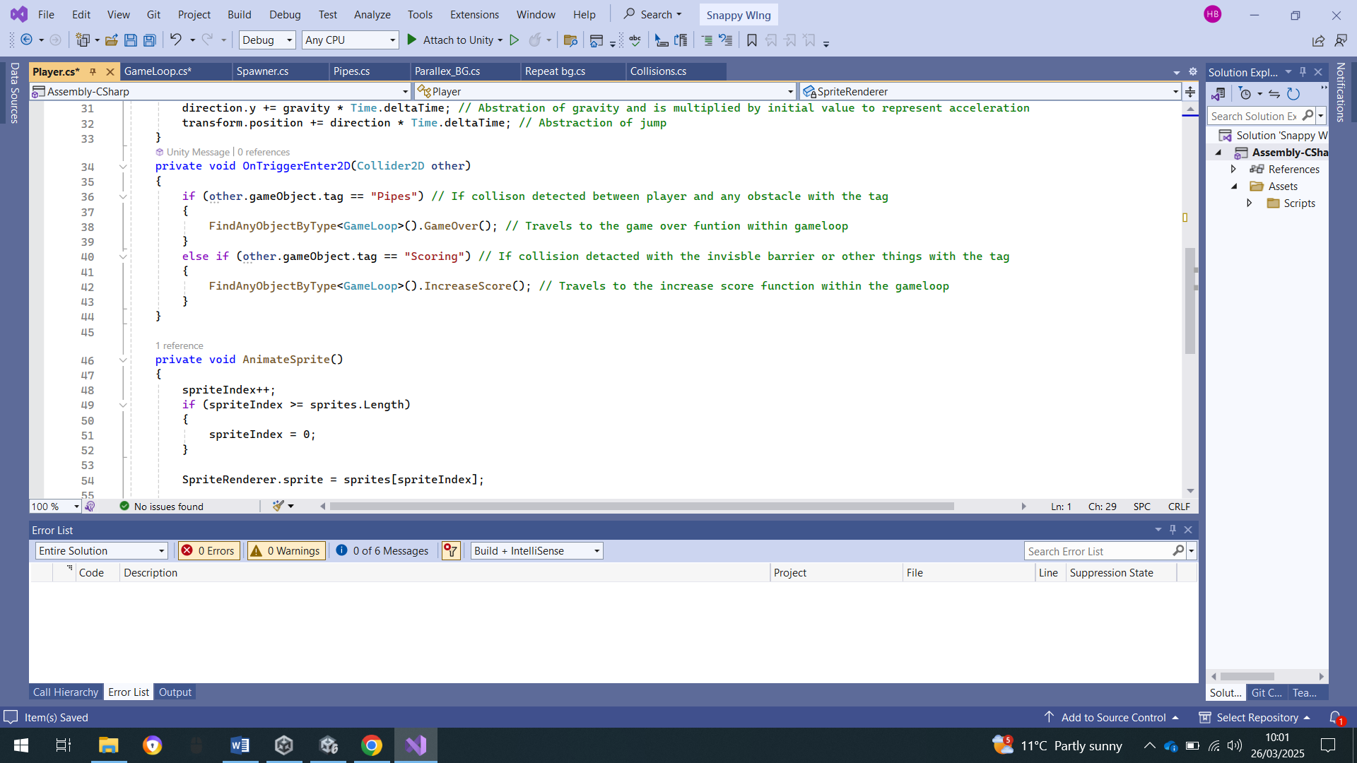 41

A problem I ran into 41

Another essential feature 41

Game loop 42

Purpose 42

Key properties 42

Another key Feature 43

A problem I ran into 44

Another essential feature 44

Problems I ran into 45

Another issue I ran into 45

Spawner 46

Purpose 46

Key feature 46

Pipes 47

Purpose 47

Key feature 47

Another key feature 48

A problem I ran into 48

Parallex_bg 49

Purpose 49

All code 51

Player Script 51

Game loop Script 53

Parallax_Bg 54

Pipes 55

Spawner 56

Evaluation 57